

A Project Report

on

**A DUAL-SWITCH COUPLED INDUCTOR-BASED**

**HIGH STEP-UP DC-DC CONVERTER**

Submitted in partial fulfilment of the Requirements for the Award of Degree

of

**BACHELOR OF TECHNOLOGY**

in

**ELECTRICAL AND ELECTRONICS ENGINEERING**

Submitted By

**E. Bhargav 19B91A0220**

**N. Bharath Raj 19B91A0219**

**B. Sai Prasad 19B91A0212**

**B. Sumanth Kumar 19B91A0215**

**D. Karthikeya 19B91A0247**

**D. Pavan Sai 19B91A0249**

Under the esteemed guidance of

**Dr. G. VEERANNA, M.Tech., Ph.D.**

**Assistant Professor, EEE Department**



## DEPARTMENT OF ELECTRICAL & ELECTRONICS ENGINEERING

## SAGI RAMAKRISHNAM RAJU ENGINEERING COLLEGE (A)

**(Affiliated to JNTU KAKINADA) (Recognized by A.I.C.T.E, New Delhi)**

**(Accredited by N.B.A., NAAC with ‘A+’ grade, New Delhi)**

**CHINNA AMIRAM, BHIMAVARAM-534204**

(2023)

**S.R.K.R. ENGINEERING COLLEGE(A)**



**(Affiliated to JNTU KAKINADA) (Recognized by A.I.C.T.E, New Delhi)**

**(Accredited by N.B.A., NAAC with ‘A+’ grade, New Delhi)**

**CHINNA AMIRAM, BHIMAVARAM-534204**

**DEPARTMENT OF ELECTRICAL AND ELECTRONICS ENGINEERING**



**Certificate**

This is to certify that Mr./Ms. E. BHARGAV, N. BHARATH RAJ, B. SAI PRASAD, B. SUMANTH KUMAR, D. KARTHIKEYA, D. PAVAN SAI of final year B. Tech., EEE, have carried out the project work on “A DUAL-SWITCH COUPLED INDUCTOR-BASED HIGH STEP-UP DC-DC CONVERTER” in partial fulfilment of the requirements for the award of the Degree of ‘Bachelor of Technology’ with specialization of Electrical and Electronics Engineering in S.R.K.R. Engineering College (A), Bhimavaram. This is a bonafide record of the work done by us during the academic year 2022 – 2023. The results of this project work have not been submitted to any other university or Institute for the award of any degree.

|  |  |
| --- | --- |
| Guide | Head of the Department |
| **Dr. G. VEERANNA, M.Tech., Ph.D.** | **Dr. B.R.K. VARMA, M.E., Ph.D.** |
| Assistant Professor | Professor & HOD |

**CERTIFICATE OF EXAMINATION**

This is to certify that we had examined the project report are hereby according to our approval of it as a study carried out and presented in a manner required for its acceptance in a partial fulfilment for the award of degree of **BACHELOR OF TECHNOLOGY** in **ELECTRICAL AND ELECTRONICS ENGINEERING** for which it has been submitted.

This approval does not necessarily endorse or accept every statement made, opinion expressed or conclusion drawn as in the report. It only signifies the acceptance of report for the purpose for which it is submitted.

**INTERNAL EXAMINER EXTERNAL EXAMINER**

**DECLARATION**

This project entitled “**A DUAL-SWITCH COUPLED INDUCTOR-BASED HIGH STEP-UP DC-DC CONVERTER**” has been carried out by me in the partial fulfilment of the requirements for the award of the degree of Bachelor of Technology in the Department of Electrical and Electronics Engineering, Sagi Rama Krishnam Raju Engineering College(A), (Affiliated to JNTUK), Bhimavaram. we hereby declare that this thesis has not been submitted to any other university/institute for the award of any other degree/diploma.

|  |  |  |  |
| --- | --- | --- | --- |
| **Roll. No.** | | **Name** | **Signature** |
| 19B91A0220 | E. BHARGAV | | _________________ |
| 19B91A0219 | N. BHARATH RAJ | | _________________ |
| 19B91A0212 | B. SAI PRASAD | | _________________ |
| 19B91A0215 | B. SUMANTH KUMAR | | _________________ |
| 19B91A0247 | D. KARTHIKEYA | | _________________ |
| 19B91A0249 | D. PAVAN SAI | | _________________ |

**ACKNOWLEDGEMENT**

Our most sincere and graceful acknowledgement is due to this sanctum, **SAGI RAMA KRISHNAM RAJU ENGINEERING COLLEGE**, for giving us opportunity to fulfil our aspiration to become an engineer.

In the first place. We would like to convey our heartfelt gratitude to **Dr. Veeranna**, Assistant Professor, Department of EEE, who offered this project to us. We owe him a great debt of gratitude for his insightful discussions, capable direction, and unwavering support throughout the project, without whom this project would not have been a success. We would like to convey our heartfelt gratitude to **Dr. B.R.K. Varma**, Head of The Department of EEE, S.R.K.R. Engineering College, Bhimavaram, for his constant support and timely advice that helped me complete my project successfully.

We gratefully acknowledge **Dr. M. JAGAPATHI RAJU**, Principal, SRKR Engineering College, Bhimavaram, for providing me with this opportunity to complete my degree.

We also thank other teaching and non-teaching staff for their assistance and help extended. We thank everyone who has contributed directly or indirectly to my project. We are grateful to my family for being a part of my vision and teaching me the values that really count in life.

**-Project associates**

19B91A0220

19B91A0219

19B91A0212

19B91A0215

19B91A0247

19B91A0249

## 

## ABSTRACT

This project proposes a dual-switch DC-DC converter with high-voltage gain. High-voltage gain is obtained by combining the coupled inductor (CI) and switched-capacitor (SC) voltage boosting techniques. Combining CI and SC techniques, the design flexibility is increased, and low voltage stresses on the semiconductor devices are achieved, which leads to the adoption of low-voltage-rating semiconductor devices with low ON-state resistance resulting in low switching and conduction losses. Unlike the conventional boost converter, thanks to the existence of leakage inductance, the output diode turns off naturally in the proposed converter, which suppresses the reverse-recovery problem and losses. Operation principle and steady-state analysis are discussed to show the advantages of the proposed DC-DC converter.

**TABLE OF CONTENTS**

ABSTRACT vi

LIST OF FIGURES ix

LIST OF TABLES xi

CHAPTER 1 (INTRODUCTION) 1

1.1 BACKGROUND 1

1.2 MOTIVIATION FOR THE PROJECT WORK 1

1.3 OBJECTIVE OF OUR PROJECT 3

1.4 ADVANTAGES OF OUR PROJECT 3

1.5 THESIS ORGANIZATION 3

CHAPTER 2 (LITERATURE REVIEW) 4

2.1 LITERATURE SURVEY 4

CHAPTER 3 (PROPOSED SYSTEM) 7

3.1 PROPOSED BLOCK DIAGRAM 7

3.2 TOPOLOGY 7

3.2.1 STRUCTURE OF THE PROPOSED DC-DC CONVERTER 7

3.1.2 OPERATION OF THE PROPOSED SYSTEM 9

3.1.3. STEADY-STATE ANALYSIS OF THE PROPOSED CONVERTER 11

CHAPTER 4 (SOFTWARE IMPLEMENTATION) 14

4.1 MATLAB SIMULINK MODELLING 14

PARAMETERS 15

4.2 SIMULATION RESULT OF THE PROPOSED DC-DC CONVERTER 15

4.3 CHAPTER CONCLUSION 17

CHAPTER 5 (HARDWARE IMPLEMENTATION) 18

5.1 TLP 350 M0SFET DRIVER 18

5.1.1 PIN CONFIGUATION ISOLATED MOSFET DRIVER TLP350 19

5.2 DSPIC CONTROLLER 20

5.2.1 DSPIC 30F2010 PIN CONFIGURATION 21

5.2.2 MOTOR CONTROL PWM MODULE IN DSPIC 22

5.2.3 DSPIC MICRO CONTROLLER FEATURES 24

5.2.4 FLOW CHART & CODE OF THE MICROCONTROLLER 25

5.3 MOSFET 31

5.3.1 WORKING PRINCIPLE OF MOSFET 33

5.3.2 N- CHANNEL MOSFET 34

5.3.3 IRF840 MOSFET 34

5.4 INDUCTOR 35

5.4.1 THE TIME CONSTANT OF AN INDUCTOR 38

5.4.2 CURRENT AND VOLTAGE IN AN INDUCTOR 40

5.4.3 POWER IN AN INDUCTOR 40

5.4.4 ENERGY IN AN INDUCTOR 41

5.4.5 ENERGY STORED BY AN INDUCTOR 41

5.5 CAPACITOR 42

5.5.1 THE CAPACITANCE OF A CAPACITOR 44

5.5.2 VOLTAGE RATING OF A CAPACITOR 47

5.6 HARDWARE VIEW 48

5.6.1 HARWARE RESULTS 48

5.7 CHAPTER CONCLUSION 51

CONCLUSION 52

REFERENCES 53

## LIST OF FIGURES

|  |  |  |
| --- | --- | --- |
| **FIG NO** | **TITLE OF FIGURE** | **PAGE NO** |
| 1. 1 | General structure of solar PV-based renewable energy system | 2 |
| 3. 1 | proposed block diagram. | 7 |
| 3. 2 | Structure of proposed converter. | 8 |
| 3. 3 | Equivalent circuit of the proposed converter. | 8 |
| 3. 4 | Equivalent circuits for operation mode of the proposed DC-DC converter- Mode I. | 9 |
| 3.5 | Equivalent circuits for operation mode of the proposed DC-DC converter- Mode II. | 10 |
| 3.6 | Equivalent circuits for operation mode of the proposed DC-DC converter- Mode III. | 10 |
| 3.7 | Equivalent circuits for operation mode of the proposed DC-DC converter- Mode IV. | 11 |
| 3.8 | The gate signals and time intervals of operation modes for the proposed converter. | 11 |
| 4.1 | Simulation diagram of the proposed converter. | 14 |
| 4.2 | Input voltage of the proposed converter. | 16 |
| 4.3 | Output voltage of the proposed converter. | 16 |
| 4.4 | Output current of the proposed converter. | 17 |
| 5.1 | TLP 350. | 18 |
| 5.2 | Pin diagram of TLP350. | 19 |
| 5.3 | TLP350 as a high side MOSFET or IGBT driver. | 20 |
| 5.4 | DSPIC30F2010 pin Configurations. | 21 |
| 5.5 | Dspic30f 2010 Architecture Functional Block Diagram. | 23 |
| 5.6 | DSPIC30F2010 Micro Controller. | 24 |
| 5.7 | Flow chart of the microcontroller code to control gate pulse. | 25 |
| 5.8 | Structure of MOSFET. | 32 |
| 5.9 | Operation in depletion mode. | 32 |
| 5.10 | Operation in enhancement mode. | 33 |
| 5.11 | MOSFET Block Diagram. | 34 |
| 5.12 | IRF840 MOSFET. | 35 |
| 5.13 | Symbol of Inductor. | 36 |
| 5.14 | Inductor coil. | 38 |
| 5.15 | Inductor Switching Circuit. | 39 |
| 5.16 | Inductor Current and Voltage Waveform. | 40 |
| 5.17 | A Typical Capacitor. | 42 |
| 5.18 | Parallel Plate Capacitor. | 45 |
| 5.19 | Hardware view. | 48 |
| 5.20 | Input voltage of the proposed converter. | 49 |
| 5.21 | Output voltage of the proposed converter. | 50 |

## LIST OF TABLES

**Table No Title of Tables Page no**

1. The Simulation parameters of the proposed converter**.** 14

2 Inductance Prefixes 28

## CHAPTER 1

INTRODUCTION

## 1.1 BACKGROUND

Renewable energy (RE) sources, including fuel cell, wind turbine, and photovoltaic (PV), are widely used recently all over the world. Solar PV energy is the cleanest and most abundant RE source available. Also, due to the lack of moving parts, PV-based RE systems benefit from a long lifetime and low maintenance costs. Most commercially available solar panels are often less than 60 V. Series connection of solar panels is often employed to achieve a high voltage.

## 1.2 MOTIVIATION FOR THE PROJECT WORK

## 

However, the biggest challenge is the limitation on the power harvesting due to the unequal current generation caused by shading, dirt, unequal aging, etc. The most common and efficient approach is integrating the solar panel with a DC-DC power converter as shown in Fig. 1, where the solar PV array is connected to the DC bus through a DC-DC power converter. This DC-DC converter plays two roles, which are providing a high-voltage conversion ratio and tracking maximum power point (MPP) of the solar panels. The required voltage conversion gain is typically higher than 10. Theoretically, the conventional boost converter is able to provide a high-voltage gain at higher duty cycle close to 1. However, practically, operating at an extreme duty cycle, the conventional boost converter suffers from high switching and conduction losses, high voltage stress across the semiconductor devices, reverse-recovery problem of the output diode, high electromagnetic interference (EMI), and effective series resistance (ESR) of the passive elements leading to low efficiency.

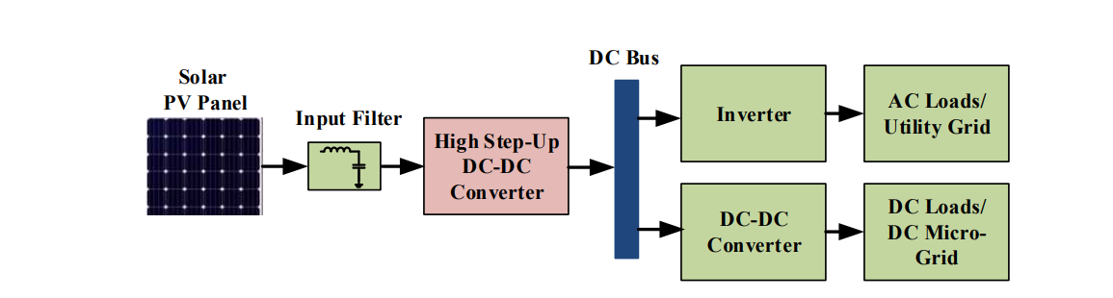

fig. 1. 2 General structure of solar PV-based renewable energy system.

Many researchers have proposed the utilization of high step-up DC-DC converters as the most practical and feasible solution to boost the low voltage of the PV array and to lower the voltage stresses on the semiconductor devices. Cascaded and multilevel converters are the simplest structures to achieve a high voltage gain, but they suffer from low efficiency due to the several stages and a large number of power switches. Quadratic converters are able to address the efficiency issue of cascaded and multilevel topologies by using a less number of power switches, however they may suffer from either voltage or current over stresses. Another technique to extend the voltage gain is integrating the conventional converters with voltage multiplier cells (VMCs), including switched-capacitor (SC), switched-inductor (SL), and the combination of SC and SL cells.

In these converters, with the transition in series and parallel connection of the inductors and capacitors, an inherent high-voltage gain is achieved. However, more VMCs must be adopted to increase the voltage gain significantly, which leads to the higher cost and complexity. Recently, in order to improve the voltage boosting capability of the high step-up converters, magnetically coupled inductor (CI) is utilized along with other voltage-boosting techniques. Employing CI, more design degrees of freedom are obtained and a wider range of voltage gain can be achieved at suitable duty cycles through adjusting the turns-ratio. However, due to the stored energy in the leakage inductance of CI, the CI-based converters suffer from the voltage spike across the power switches which can be simply resolved by means of an active/passive clamp circuit. A dual-switch CI-based DC-DC converter with high-voltage gain is proposed, which is suitable for PV applications. The dual-switch structure is used to reduce the current stress of switches. A two-winding CI is integrated with SC cells to realize high-voltage gain, low voltage stresses on the power switches and diodes, alleviation of the output diode reverse-recovery problem, and high efficiency due to the adoption of low-voltage-rating semiconductor devices with low ON-state resistance.

## 1.3 OBJECTIVE OF OUR PROJECT

* To implement high gain DC-DC boost converter with dual switches.
* To reduce the voltage stress across the switches
* To reduce the switching losses in the proposed scheme.

## 1.4 ADVANTAGES OF OUR PROJECT

* High voltage boost ratio.
* High static gain.
* Low switching losses.
* Low switching stress due to high static gain.
* Efficiency is high.

## 1.5 THESIS ORGANIZATION

* CHAPTER 1 – INTRODUTION
* CHAPTER 2 – LITERATURE REVIEW
* CHAPTER 3 – PROPOSED SYSTEM
* CHAPTER 4 –SOFTWARE IMPLEMENTATION
* CHAPTER 5-HARDWARE IMPLEMENTATION
* CONCLUSION

## CHAPTER 2

LITERATURE REVIEW

## 2.1 LITERATURE SURVEY

**Transformer less dc-dc converter with high voltage gain based on a switched-inductor structure applied to photovoltaic systems by julio c. S. De morais1 roger gules juliano l. S. De morais leonardo g.fernandes**

In photovoltaic (PV) systems, high step-up dc-dc converters are required to manage the power flow. Since the output voltage of photovoltaic source is lower than the grid voltage level, dc-dc converters with high voltage gain are the solution in transformer less topologies. A high step-up dc-dc C´uk converter with switched-inductor is proposed in this paper. The presented topology is designed to application in current source inverters (CSI) and unfolding inverters.

**Employing Dc-Dc Converter with Two Input Boost Stages to Achieve High Voltage Gain by Maliha khan1 and Rajshree Thakre**

A high-voltage-gain technique employing dc-dc power electronic converters is proposed. The suggested topologies can be used as multiport converters and draw continuous current from two input sources. They can also draw continuous current from a single source in an interleaved manner. The proposed converter can easily achieve a gain of 12 while getting a continuous input current. Such a converter can individually link a PV panel to a 100-Vdc bus. The combination of non-isolated boost interleaved converter helps to obtain high step-up gain without operating in a high duty ratio condition. Through interleaved manner, a continuous current can be drawn from the given input sources. This converter can reduce the input current ripple and current stress which results in the increase the lifetime of the input source and the decrease in conduction losses. These advantages make this in appealing for renewable applications such as solar systems, microgrid systems etc. Also, they can be used to interface the 400-V DC bus in a microgrid system using the low power voltage sources like batteries, photovoltaic (PV) panels, fuel cells, etc.,

**Double-input High-gain Bidirectional DC-DC Converter For Hybrid Energy Storage Systems In DC-Micro Grid by P.Mohammadi and J . S. Moghani**

The Double-input High-gain Bidirectional DC-DC Converter for Hybrid Energy Storage Systems. In DC-Micro Grid converter can achieve ZVS operation for all of the switches, with the combination of quasi resonant and active clamp techniques. The proposed converter does not utilize transformer for achieving high gain, hence the number of switches is decreased in comparison to its counterparts. Therefore, it has better reliability and it is more cost effective. Furthermore, proposed converter utilizes just four switches in each mode, hence the conduction loss is decreased considerably. Also, unlike its isolated counterparts which use phase shift technique, it has excellent voltage matching. Accordingly, the circulating current that causes current stress and loss in isolated converters naturally does not exist. The switching strategy of the converter is presented and simulations for different modes of the converter is carried out to demonstrate the performance of converter in different modes.

**Z-source-based isolated high step-up converter by F. Evran and M. T. Aydemir**

A new non-isolated high step-up Quasi Z-source dc-dc converter with coupled inductor techniques is presented, which is suitable for renewable applications. The main advantages of the proposed topology are continuous input current, common ground between load and input DC source, low normalized voltage stress on the semiconductors (switch/diodes) and low total voltage stress on devices compared to the conventional QZS converter. However, increasing the turn’s ratio value of the coupled inductor windings not only doesn’t limit the duty cycle but also leads to decrease the voltage stress on switch/diodes and increase the output voltage level.

**A Novel High Step-Up Dual Switches Converter with Coupled Inductor and Voltage Multiplier Cell for a Renewable Energy System by H. Liu, F. Li, and J. Ai**

A novel high step-up converter, which is suitable for renewable energy system, is proposed in this paper. The proposed converter is composed of the dual switches structure, three-winding coupled inductor and two voltage multiplier cells in order to achieve the high step-up voltage gain. The dual switches structure is beneficial to reduce the voltage stress and current stress of the switch. In addition, two multiplier capacitors are respectively charged during the switch-on period and switch-off period, which increases the voltage conversion gain. Meanwhile, the energy stored in the leakage inductor is recycled with the use of clamped capacitors. Thus, two main power switches with low on-resistance and low current stress are available. As the leakage inductor, diode reverse-recovery problem is also alleviated. Therefore, the efficiency is improved.

From these papers we have learnt that this converter is better when compared to other boost converters i.e., voltage gain is high, efficiency is high, losses are reduced. Switches are decreased in comparison to its counter parts. Therefore, it has better reliability and it is more cost effective. This converter utilizes just four switches in each mode. Hence the conduction loss is decreased considerably. So, the circulating current that causes current stress and loss in isolated converters naturally does not exist.

# 

## CHAPTER 3

PROPOSED SYSTEM

## 3.1 PROPOSED BLOCK DIAGRAM

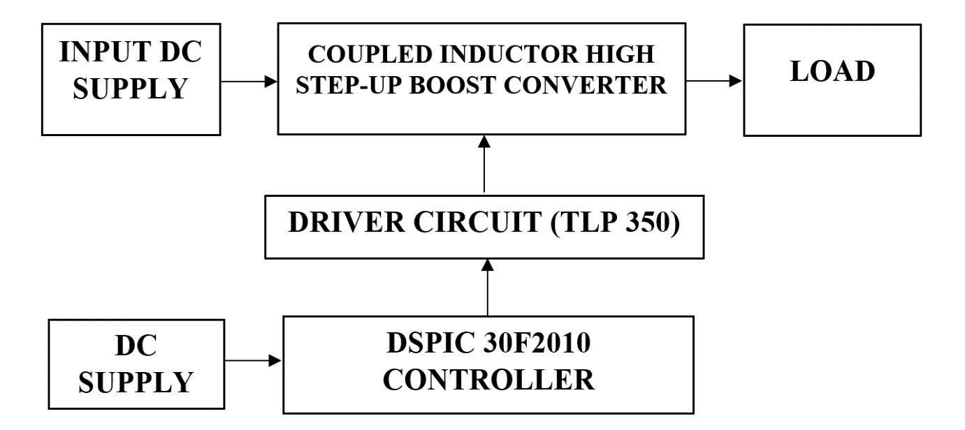

fig. 3. 1. proposed block diagram.

The fig 3.1 shows the block diagram of the proposed system in mainly consist of a Coupled inductor high step boost coveter with single switch the switch frequency and the duty cycle are controlled by the DSPIC30f2010 controller. By controlling this the output voltage is boosted.

## 3.2 TOPOLOGY

### 3.2.1 STRUCTURE OF THE PROPOSED DC-DC CONVERTER

The structure of the proposed converter is shown in Fig. 3.2. As illustrated in this figure, the proposed converter consists of two power switches ($S_{1}$, $S_{2}$), five diodes ($D_{1},D_{2},D_{3},D_{4},D_{o}$), four capacitors ($C_{1}$, $C_{2}$, $C_{3}$, $C_{o}$), and one CI with two windings. The equivalent circuit of the proposed topology is demonstrated in Fig. 3.3 in which the two-winding CI is modelled with an ideal transformer with $N_{1}$ and $N_{2}$ as the number of turns in the primary and secondary sides, respectively, a magnetizing inductance $L_{m}$ in the primary side, and leakage inductances $L_{k1}$ and $L_{k2}$ in the primary and secondary sides, respectively. Switches $S_{1}$ and $S_{2}$ share the same operation signal. Parameters $V_{in}$, $V_{o}$, and R represent the input voltage, the output voltage, and the load resistance, respectively.

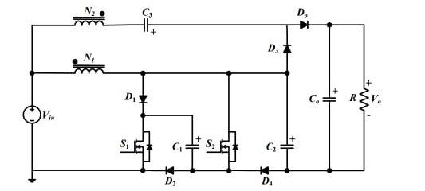

fig. 3. 2 Structure of proposed converter.

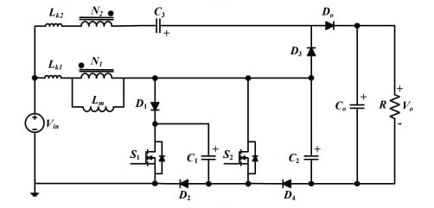

fig. 3. 3 Equivalent circuit of the proposed converter.

### 3.1.2 OPERATION OF THE PROPOSED SYSTEM

The proposed converter is assumed to operate in continuous conduction mode (CCM). All components are considered ideal without parasitic elements except the leakage inductances of the CI. All the capacitors are assumed to be large enough to have a constant voltage over the switching period Ts. The gate signals of the switches are applied simultaneously with a duty cycle less than 50 %. The operation principle of the proposed converter is divided into four operation modes during one switching period.

The equivalent circuits of the proposed converter for the operation modes are illustrated in Fig. 3.3, which are explained as the following:

**Mode I**: In this mode, both switches $S_{1}$ and $S_{2}$ start to conduct simultaneously. Diodes $D_{1},D_{2 }and D_{4}$ turn off, while diode $D_{3}$ remains in ON-state from the previous mode (mode IV). The leakage inductance Lk1 and the magnetizing inductance $L_{m}$ are charged by the input source and, consequently, their currents increase. Capacitor $C_{1}$ starts to be discharged, capacitor $C_{3}$ keeps being charged through the secondary winding of the CI, and capacitor $C_{o}$ keeps suppling the load. As the current ${iL}_{k2}$ reaches zero, this mode ends. Mode I is a transition mode with a very short time.

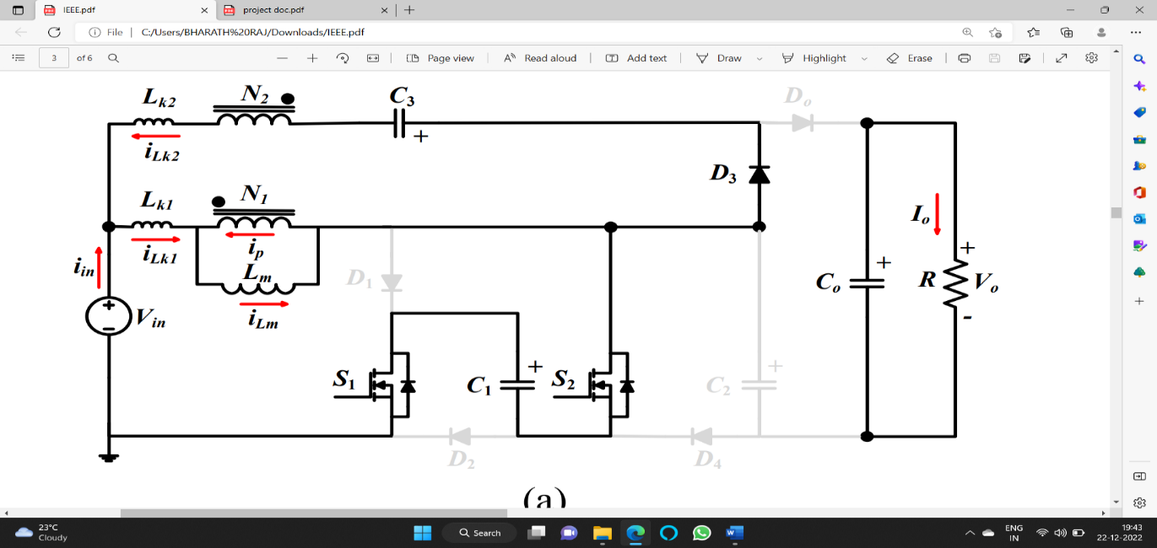  
fig. 3. 4 Equivalent circuits for operation mode of the proposed DC-DC converter- Mode I.

**Mode II**: At the beginning of this mode, diode $D_{3}$ turns off with zero current switching (ZCS) condition, while diode $D_{0}$ turns on with ZCS condition to transfer the energy to the output capacitor $C_{o}$ and the load R. During this mode, capacitors $C_{1}{,C}_{2}$ and $C_{3}$ are discharged and the output capacitor $C_{o}$ is charged. At the end of this mode, the currents of all the inductances reach their maximum values.

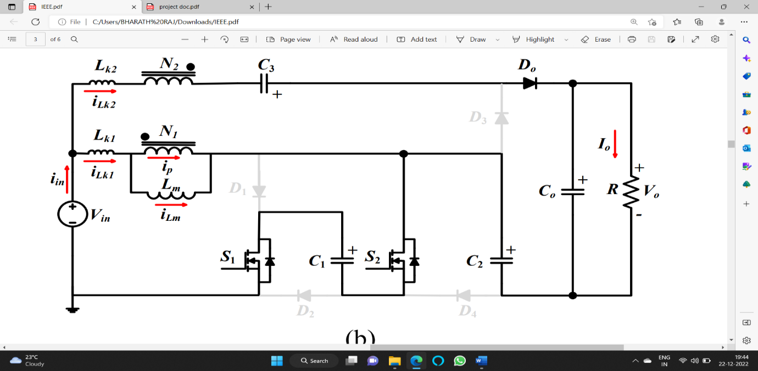

fig. 3. 5 Equivalent circuits for operation mode of the proposed DC-DC converter-Mode II.

**Mode III**: the equivalent circuit for this mode. In this mode, both switches $S_{1}$ and $S_{2}$ turn off. The diodes $D_{1},D_{2 },and D_{3}$ turn on, and a clamp circuitry is provided to absorb the stored energy in the leakage inductance and to alleviate the voltage spikes on the power switches. All inductances start to be discharged in this mode. Thus, all the currents ${iL}_{k1},{iL}_{k2}$, ${iL}_{m},$ and $i_{p}$ decrease towards zero during this mode. Like mode I, this mode is a transition mode with a very short duration.

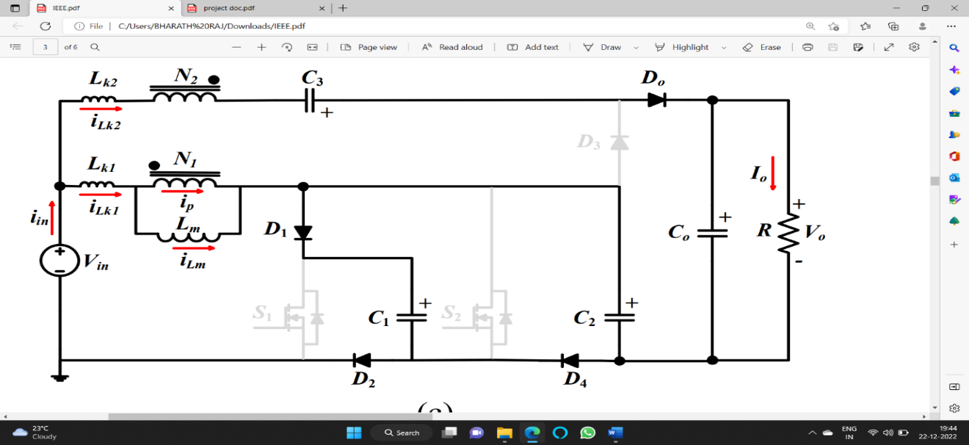

fig. 3. 6 Equivalent circuits for operation mode of the proposed DC-DC converter-Mode III.

**Mode IV**: This mode, presented in fig. 3.7, begins as the output diode ${ D}_{o}$ turns off under ZCS condition and diode $D_{3}$ turns on under ZCS condition. During this mode, capacitors $C_{1}{,C}_{2}$ and $C_{3}$ are charged, while capacitor $C_{o}$ is discharged and supplies the load. It is clear that thanks to the existence of the leakage inductance of CI, the output diode turns off with ZCS condition, which eliminates the reverse-recovery problem.

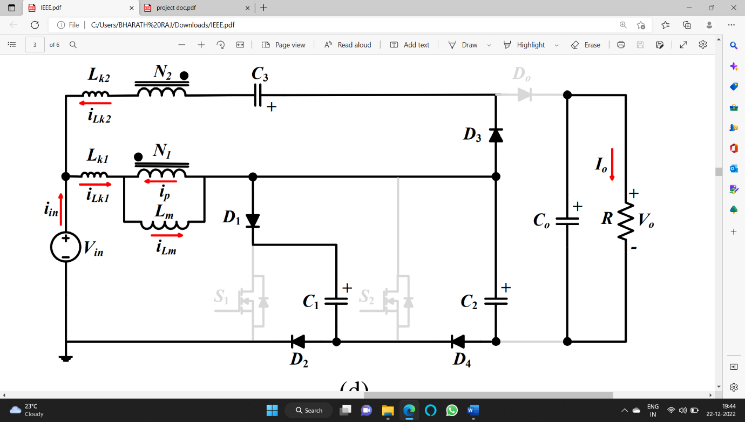

fig. 3. 7 Equivalent circuits for operation mode of the proposed DC-DC converter-Mode IV.

### 3.1.3. STEADY-STATE ANALYSIS OF THE PROPOSED CONVERTER

**Static Voltage Gain**

To simplify the steady-state analysis, the leakage inductances are ignored and the CI is assumed to be well coupled. Neglecting the leakage inductances, operation modes I and III are ignored, and then the operation principle is simplified to two main modes II and IV. In mode II, switches $S_{1}$ and $S_{2}$ turn on and the magnetizing inductance $L_{m}$ is charged, however $L_{m}$ is discharged in mode IV when $S_{1}$ and $S_{2}$ turn off. N=N2/N1 is the turns-ratio of the CI, and the duty cycle range of the proposed converter is from 0 to 0.5.

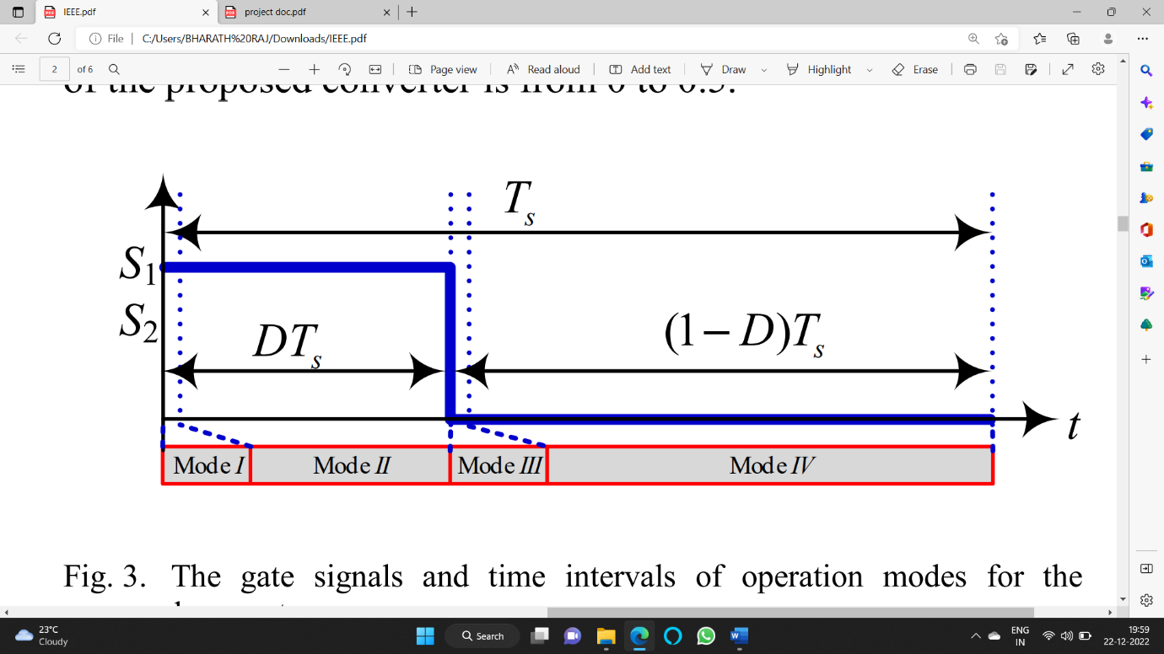

fig. 3. 8 The gate signals and time intervals of operation modes for the proposed converter.

Applying the KVL to the loops is Fig. 3.5 and Fig.3.7, the voltage across Lm is determined as:

$V_{Lm}^{II}$ = $V_{in}+V_{C1}$

$V_{Lm}^{IV}$ = $V_{in} -{ V}_{C1}$ (3.1)

Applying the volt-second balance law on the magnetizing inductance, the following equation can be written:

$$\int_{0}^{DT}{V_{Lm}}+\int_{DT}^{T}{V_{Lm}}=0$$

$$V_{Lm}^{II}+V_{Lm}^{IV}(1-D)T=0 (3.2)$$

Substituting (1) into (2), the following voltage relationships are obtained:

$$V_{C1}=\frac{1}{1-2D}V_{in} (3.3)$$

$$V_{Lm}^{II}=\frac{2(1-D)}{1-2D}V_{in} (3.4)$$

$$V_{Lm}^{IV}=\frac{-2D}{1-2D}V_{in} (3.5)$$

Applying the KVL to the loops is Fig. 4, the voltages across capacitors $C_{2}$, $C_{3}$, and $C_{0}$ are derived as:

$$V_{C2}=V_{C1}=\frac{1}{1-2D}V_{in} (3.6)$$

$$V_{C3}=-(N+1)V_{Lm}^{IV}=\frac{2(N+1)D}{1-2D}V_{in} (3.7)$$

$$V_{C0}=(N+1)V_{Lm}^{II}+V_{C2}+V_{C3}=\frac{2N+3}{1-2D}V_{in} (3.8)$$

From (8), the static voltage gain is achieved as:

$$M=\frac{V_{C0}}{V_{in} }=\frac{V_{O}}{V_{in} }=\frac{2N+3}{1-2D} (3.9)$$

According to the above relationship, the voltage gain is a function of two parameters: turns-ratio of the CI and duty cycle of the power switches, thus there are two degrees of freedom to adjust the voltage gain.

**Voltage Stresses of Power Switches and Diodes**

In the proposed DC-DC converter, voltages of the capacitors are constant, because they are supposed to be large enough. Thus, the voltage stresses across the power switches and diodes can be obtained by:

$V_{Sj}=V_{Dk}=V_{C1}=\frac{1}{1-2D}V_{in}=\frac{1}{2N+3}V_{O}$ (3.10)

(For j=1,2 and k=1,2,4)

$V_{D3}=V_{D0}=V_{O}-V_{C2}=\frac{2N+2}{1-2D}V_{in}=\frac{2N+2}{2N+3}V_{O}$ (3.11)

From (3.10) and (3.11), it is clear that the voltage stresses on the power devices are less than the output voltage, which enables the designer to select low-voltage-rated switches and diodes with low ON-state resistance, which causes lower switching and conduction losses. Additionally, it can be seen that as the turns-ratio of CI increases, the voltage stresses of the power switches decrease with respect to the output voltage.

**Average Current stresses of Power Switches and Diodes**

According to the ampere-second balance law, the average current of the capacitors is zero for a switching cycle. Knowing this fact, the average current relationships of inductors and semiconductor devices can be derived as:

$I_{Lm,avg}=I_{Lk1,avg}=I_{in,avg}=MI_{o}=\frac{2N+3}{1-2D}I_{o}$ (3.12)

$I_{Lk2,avg}=0 (3.13)$

$$I_{S1,avg}=I_{S2,avg}=I_{D1,avg}=\frac{1}{2}(I_{Lm,avg}-I_{o})=\frac{N+D+1}{1-2D}I_{o} ( 3.14)$$

$$I_{D2,avg}=I_{S2,avg}+I_{o}=\frac{N-D+2}{1-2D}I_{o } (3.15)$$

$I_{D3,avg}=I_{D4,avg}=I_{o } (3.16)$

## CHAPTER 4

**SOFTWARE IMPLEMENTATION**

## 4.1 MATLAB SIMULINK MODELLING

This chapter present the Simulink block model of Dual Switch Coupled Inductor based High Step-up Dc-Dc Converter. The simulation diagram is shown in fig 4.1.

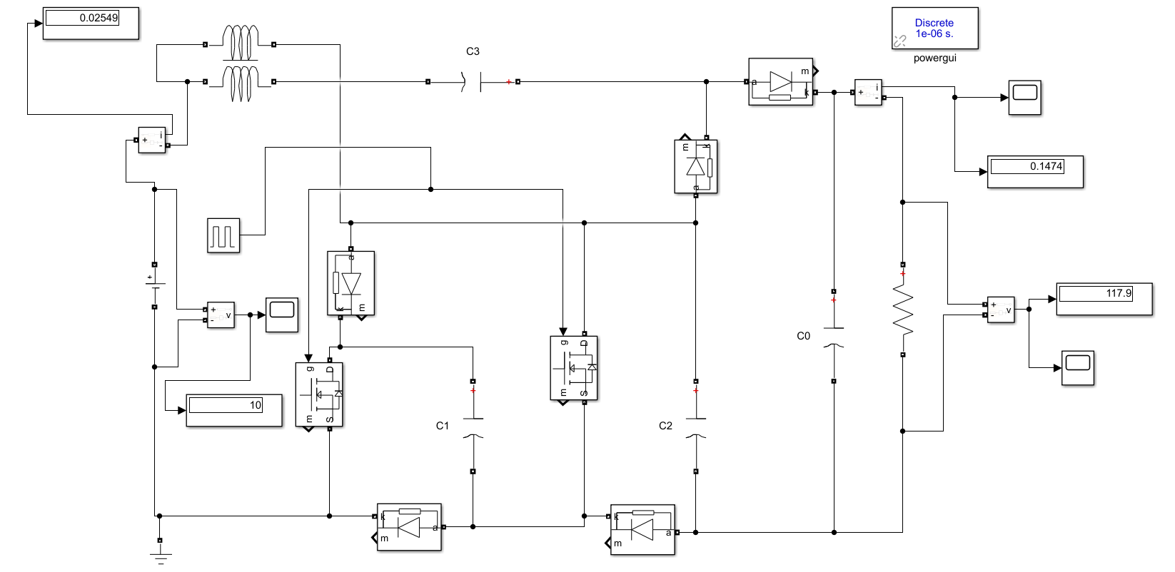

fig. 4. 1 Simulation diagram of the proposed converter.

The simulation of Dual Switch Coupled Inductor High Step-up Dc-Dc Converter was carried out in MATLAB R2018a.

The Simulation circuit consist of Dc Input Voltage Source, MOSFET, Diode, Capacitor, Mutual Inductance block, Resistive Load as series RLC branch, Pulse Generator, etc.

The parameters used for simulation are given Tabulation shown below.

|  |  |
| --- | --- |
| PARAMETERS | VALUES |
| Input voltage ($V_{in}$) | 10V |
| Load Resistance (R) | 800 Ω |
| Switching frequency ($f_{s}$) | 100Hz |
| Turns-Ratio (N) | 1 |
| $$C_{o}$$ | 150µF |
| $$C_{1}$$ | 150µF |
| $$C_{2},C_{3}$$ | 22µF |
| Duty cycle (D) | 0.375 |
| Output Voltage ($V_{out}$) | 117.9V |

Table 1: The Simulation parameters of the proposed converter

### 4.2 SIMULATION RESULT OF THE PROPOSED DC-DC CONVERTER

In order to evaluate the converter performance and the theoretical calculations, the proposed converter is simulated in MATLAB R2018a. Table 1 shows the converter parameters used to perform the simulation. Having gate signals with duty cycle of 37.5 % and the switching frequency is 100KHz with turns-ratio of 1, the ideally calculated static voltage gain (M) is 11.7, which gives a calculated output voltage of 117.9 V from the input voltage of 10 V. The output current is Vo/R=117.9/800=0.15 A. The observed average value is approximately 30 A for currents $i_{in }$ and $i_{Lm}$ 0 A for current $i_{Lk2}$, which is in agreement with the calculated value from (3.12) and (3.13), all the currents increase during the ON-state of the switching S1 and S2 (modes I and II), while decrease during OFF-state of switches (modes III and IV).

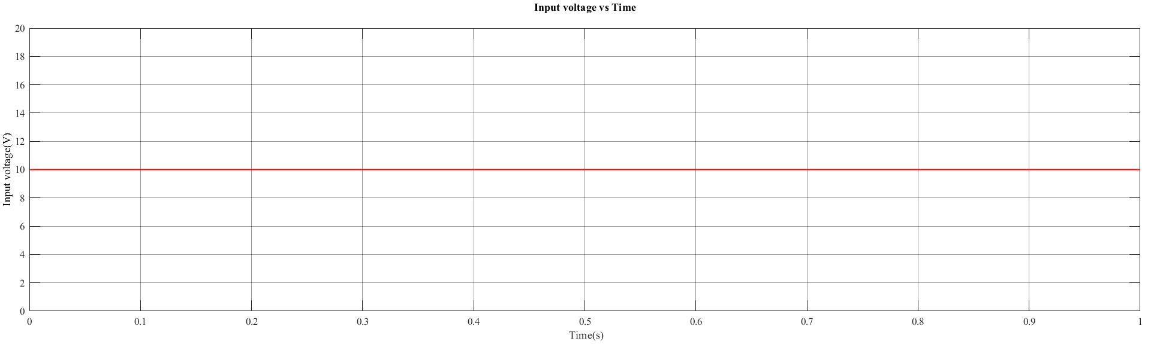

fig. 4. 2 Input voltage of the proposed converter.

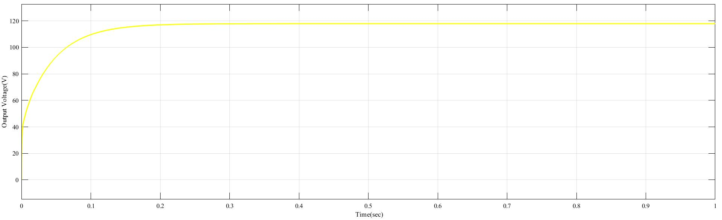

fig. 4. 3 Output voltage of the proposed converter.

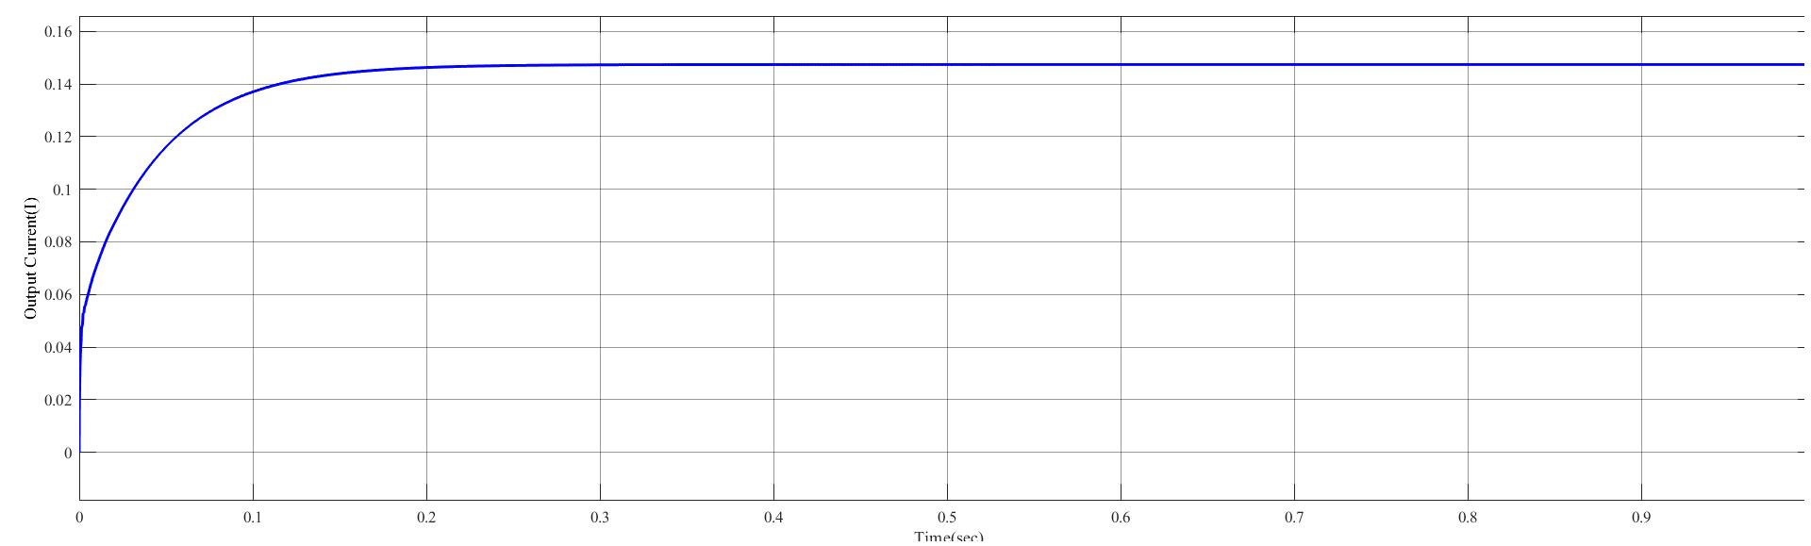

fig. 4. 4 Output current of the proposed converter.

## 4.3 CHAPTER CONCLUSION

The dual switch coupled inductor-based DC to DC converter has been successfully designed to convert an input voltage of 10V to an output voltage of 117.9V with a gain of 12%. The converter utilizes two switches, coupled inductors, and a capacitor to achieve high efficiency and low output ripple. The design process involved selecting appropriate components and ensuring the stability and performance of the converter through simulation. The converter has demonstrated excellent performance with high efficiency, low output ripple, and fast transient response. Overall, the dual switch coupled inductor-based DC to DC converter is a reliable and efficient solution for voltage conversion applications.

## CHAPTER 5

HARDWARE IMPLEMENTATION

### 5.1 TLP 350 M0SFET DRIVER

Gate driver circuit is circuit integral part of power electronics converters which is used to drive power semiconductor devices like BJT’s, IGBT’s and MOSFETs. Output of DC-DC converters mainly depend on behaviour of gate driver circuits. Its mean if gate driver circuit doesn’t drive gate of MOSFET device properly, your designed DC-DC converter output will not be according to your requirement. Therefore, design of gate driver circuit is critically important in designing of power electronics converters.

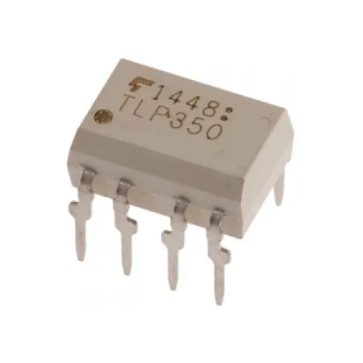

fig. 5. 1 TLP 350.

The TOSHIBA TLP350 consists of a GaAℓAs light-emitting diode and an integrated photodetector. This unit is an 8-lead DIP package. The TLP350 is suitable for gate driving IGBTs or power MOSFETs.

* Peak output current: IO = ±2.5A (max)
* Guaranteed performance over temperature: -40 to 100°C
* Supply current: ICC = 2 mA (max)
* Power supply voltage: VCC = 15 to 30 V
* Threshold input current: IFLH = 5 mA (max)
* Switching time (tpLH/tph) : 500 ns (max)

### 5.1.1 PIN CONFIGUATION ISOLATED MOSFET DRIVER TLP350

The TLP350 is a high-speed isolated MOSFET driver that is capable of driving a wide range of N-channel power MOSFETs. Here's the pin configuration of the TLP350:

Input 1 (IN1): This pin is the input pin of the first channel of the TLP350. The input signal is isolated from the output side.

Input 2 (IN2): This pin is the input pin of the second channel of the TLP350. The input signal is isolated from the output side.

Output 1 (OUT1): This pin is the output of the first channel of the TLP350. The output is used to drive the gate of an N-channel MOSFET.

Output 2 (OUT2): This pin is the output of the second channel of the TLP350. The output is used to drive the gate of an N-channel MOSFET.

Ground (GND): This pin is connected to the ground of the circuit.

Power Supply (+VCC): This pin is connected to the positive power supply voltage. The typical voltage range is between 4.5 V and 5.5 V.

Sense (S): This pin is used to sense the drain-source voltage of the MOSFET and is used for protection against overcurrent and overvoltage conditions.

Common (COM): This pin is used to provide a common return path for the input and output signals.

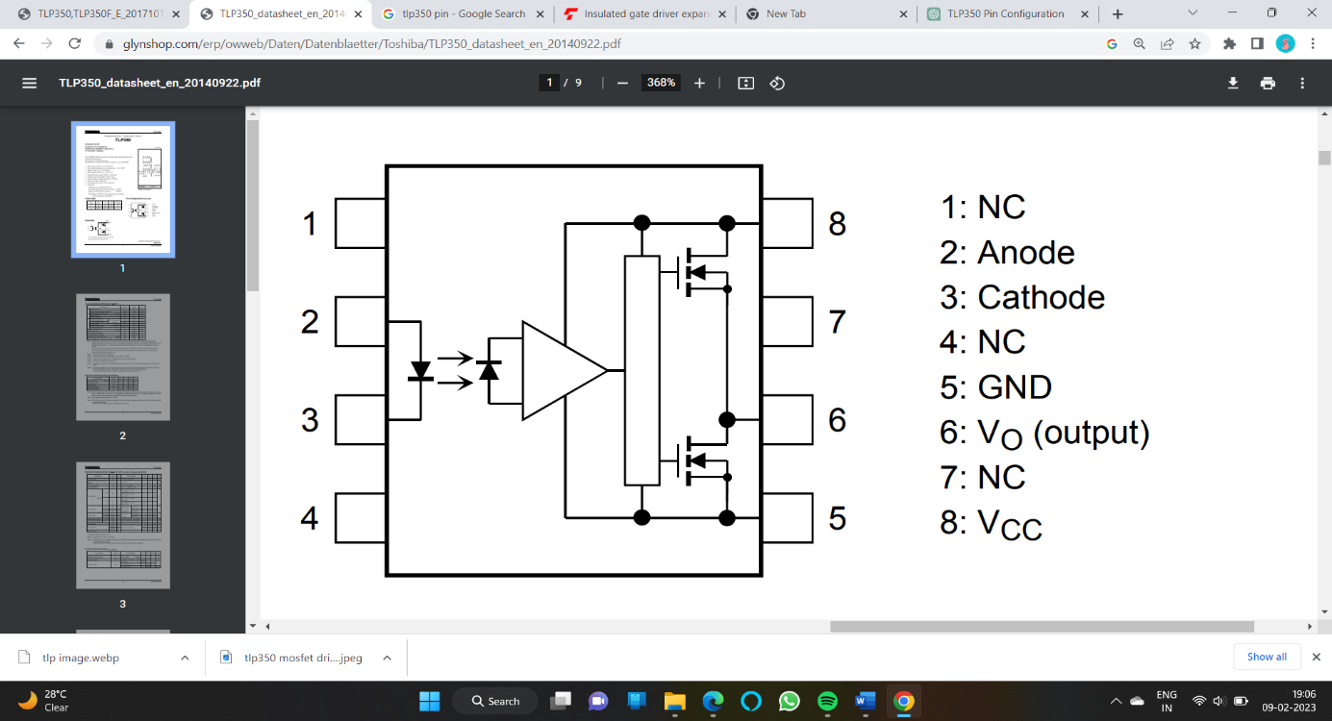

fig. 5. 2 Pin diagram of TLP350.

A typical MOSFET driver circuit can be constructed using the TLP350 as follows:

Input Signal Circuit: The input signal is applied to the input pins (IN1 or IN2) of the TLP350. The input signal can be a digital signal or an analog signal.

Power Supply Circuit: The TLP350 requires a DC power supply voltage between 4.5 V and 5.5 V. This voltage should be connected to the VCC pin. The GND pin should be connected to the ground of the circuit.

Output Circuit: The output pins (OUT1 or OUT2) of the TLP350 are connected to the gate of an N-channel MOSFET. The drain of the MOSFET is connected to the load, and the source is connected to the ground of the circuit.

Sense Circuit: The sense pin (S) of the TLP350 is used to sense the drain-source voltage of the MOSFET. This pin is connected to the drain of the MOSFET.

Common Circuit: The common pin (COM) of the TLP350 is used to provide a common return path for the input and output signals.

Top of Form

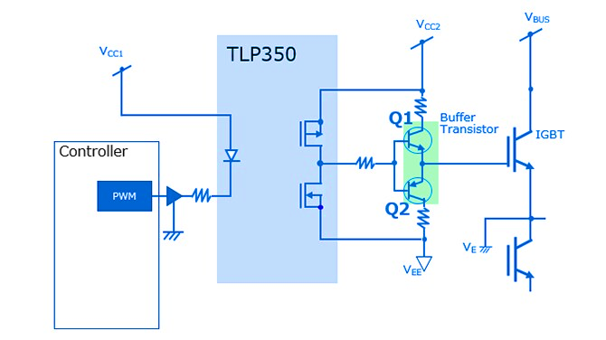

fig. 5. 3 TLP350 as a high side MOSFET or IGBT driver.

### 5.2 DSPIC CONTROLLER

Microchip Technology’s Motor Control & Power Conversion family of dsPIC Digital Signal Controllers provides an easy-to-use solution for applications requiring motor control. Microchip Technology introduced 20 16-bit Flash micro controllers that provide the industry’s highest performance.

The DSPIC family of Digital Signal Controllers features a fully- implemented digital signal processor (DSP) engine, 30 MIPS non-pipelined performance, C compiler friendly design, and a familiar Microcontroller architecture and design environment. The 20 new dsPIC30F2010 devices form three product families targeting motor control and power conversion, sensor, and general-purpose applications.

The dsPIC core is a 16-bit (data) non-pipelined modified Harvard machine that combines the control advantages of a high-performance 16-bit Microcontroller with the high computation speed of a fully implemented DSP to produce a tightly coupled, single-chip single-instruction stream solution for embedded systems designs. The initial 20-dsPIC30F2010devices feature 12 Kbytes to 144 Kbytes of on-chip secure Flash program memory space and up to eight Kbytes of data space Operating voltage appeals to many Microcontroller applications that remain at 5 volts, while many DSPs are restricted to 3.3-supply Voltage maximum. Devices are planned in 40-pin package.

### 5.2.1 DSPIC 30F2010 PIN CONFIGURATION

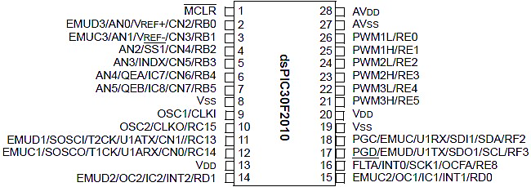

fig. 5. 4 DSPIC30F2010 pin Configurations

### 

### 5.2.2 MOTOR CONTROL PWM MODULE IN DSPIC

The dsPIC motor control PWM module is optimized for applications, such as3-phase AC induction motors, 3-phase brushless DC motors, and switched reluctance motors.

The motor control PWM module has either 6 or 8 output pins and 3 or 4 PWM generators, depending upon the device. The output pins may be configured as complementary output pairs or as independent outputs.

Critical PWM operating parameters, such as output polarity, are programmed in non-volatile memory for safety. The non-volatile options reduce the risk of placing the PWM outputs in a state that might damage the power devices connected to Peripheral.

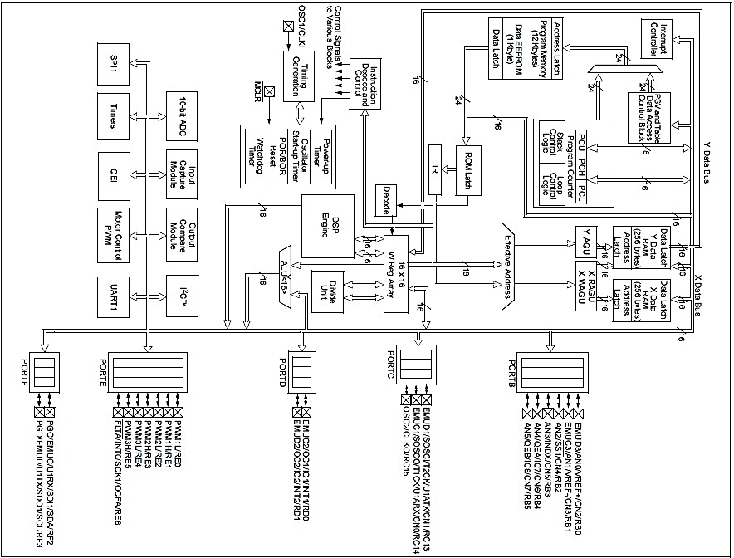

fig. 5. 5 Dspic30f 2010 Architecture Functional Block Diagram

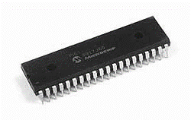

fig. 5. 6. DSPIC30F2010 Micro Controller.

## 5.2.3 DSPIC MICRO CONTROLLER FEATURES

**High Performance Modified RISC CPU**

* Modified Harvard architecture.
* C compiler optimized instruction set architecture with flexible addressing modes.
* 24-bit wide instructions, 16-bit wide data path.
* 48 Kbytes on-chip Flash program space (16K Instruction words).
* 2 Kbytes of on-chip data RAM.
* 1 Kbytes of non-volatile data EEPROM.

**MOTOR CONTROL PWM MODULE FEATURES**

* Six PWM output channels.

- Complementary or Independent Output modes.

- And Centre Aligned modes.

* Three duty cycle generators.
* Dedicated time base.
* Programmable output polarity.
* Dead-time control for Complementary mode.
* Manual output control.
* Trigger for A/D conversions.

**PERIPHARAL FEATURES**

* High current sink/source I/O pins: 25 mA/25 mA.
* Timer module with programmable presale.
* Five 16-bit timers/counters; optionally pair.
* 16-bit timers into 32-bit timer modules.
* 16-bit Capture input functions.
* 16-bit Compare/PWM output functions.
* 2 UART modules with FIFO Buffers.
* 1 CAN modules, 2.0B complain.

## 5.2.4 FLOW CHART & CODE OF THE MICROCONTROLLER

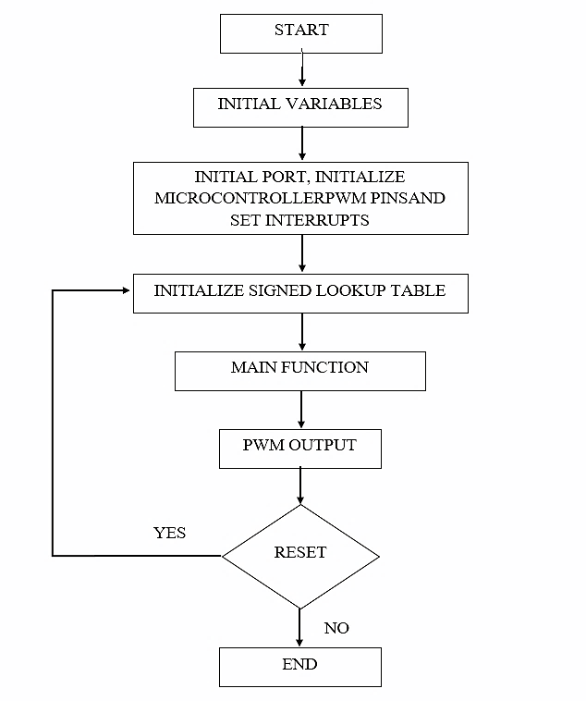

fig. 5.7. Flow Chart of The Microcontroller Code to Control Gate Pulse.

The flowchart illustrates the process of the execution of the code. To dump a code into a microcontroller using PICKIT 2 software and Mikro C, you will first need to connect the PICKIT 2 programmer to your computer and the microcontroller. Once the connections have been established, open the PICKIT 2 software and select the "Programmer-To-Go" option. Next, select the appropriate microcontroller from the list and click on the "Read Device" button to verify that the connection has been established successfully. Then, open the Mikro C software and compile the code that you want to upload to the microcontroller. Finally, select the "Export HEX File" option and save the file to your computer. Back in the PICKIT 2 software, select the "Import Hex" option and locate the HEX file that you just saved. Click on the "Program" button to upload the code to the microcontroller. Once the process is complete, disconnect the PICKIT 2 programmer from the microcontroller and your code should now be running on the microcontroller.

**CODE**

#include <p30F2010.h>

FOSC(CSW_FSCM_OFF & XT_PLL8);//Oscillator configuration registers (FOSC)

FWDT(WDT_OFF);//Configuration registers of the watchdog timer (FWDT)

unsigned int flag=0,cnt=75,cntISR,v,i,p;

struct{

unsigned int ReadI1;

unsigned int ReadI2;

}System;

typedef struct{

unsigned int AIn;

unsigned int MIn;

unsigned int RIn;

unsigned int Avg;

unsigned int Sum;

}Analog;

Analog I1 = {0,0,0,0,0};

Analog I2 = {0,0,0,0,0};

const signed int lookup[256] ={0,807,1614,2420,3224,4027,4827,5624,6417,7207,7992,8773,9548,

10317,11080,11837,12586,13328,14061,14786,15502,16208,16905,

17592,18267,18932,19585,20226,20855,21472,22075,22665,23241,

23803,24351,24883,25401,25903,26390,26860,27315,27752,28173,

28577,28963,29332,29683,30016,30330,30627,30904,31163,31403,

31624,31826,32008,32171,32315,32439,32543,32627,32692,32737,

32761,32766,32751,32717,32662,32587,32493,32379,32246,32092,

31920,31728,31516,31286,31036,30768,30481,30175,29851,29510,

29150,28772,28377,27965,27536,27090,26627,26149,25654,25144,

24619,24079,23524,22955,22372,21775,21165,20542,19907,19260,

18601,17931,17250,16558,15856,15145,14425,13695,12958,12212,

11459,10700,9933,9161,8383,7600,6813,6021,5226,4427,3626,2822,

2017,1211,404,-404,-1211,-2017,-2822,-3626,-4427,-5226,-6021,

-6813,-7600,-8383,-9161,-9933,-10700,-11459,-12212,-12958,-13695,

-14425,-15145,-15856,-16558,-17250,-17931,-18601,-19260,-19907,

-20542,-21165,-21775,-22372,-22955,-23524,-24079,-24619,-25144,

-25654,-26149,-26627,-27090,-27536,-27965,-28377,-28772,-29150,

-29510,-29851,-30175,-30481,-30768,-31036,-31286,-31516,-31728,

-31920,-32092,-32246,-32379,-32493,-32587,-32662,-32717,-32751,

-32766,-32761,-32737,-32692,-32627,-32543,-32439,-32315,-32171,

-32008,-31826,-31624,-31403,-31163,-30904,-30627,-30330,-30016,

-29683,-29332,-28963,-28577,-28173,-27752,-27315,-26860,-26390,

-25903,-25401,-24883,-24351,-23803,-23241,-22665,-22075,-21472,

-20855,-20226,-19585,-18932,-18267,-17592,-16905,-16208,-15502,

-14786,-14061,-13328,-12586,-11837,-11080,-10317,-9548,-8773,

-7992,-7207,-6417,-5624,-4827,-4027,-3224,-2420,-1614,-807, 0};

void __attribute__((__interrupt__)) _T2Interrupt(void)

{

I1.AIn = ADCBUF1; // adc0. // 2nd pin.

I2.AIn = ADCBUF2; // adc0. // 2nd pin.

// I5.AIn = ADCBUF4; // adc0. // 2nd pin.

// if(PORTDbits.RD1 == 1)

// {

//

// }

// else if(PORTDbits.RD1 == 0)

// {

// I1.RIn = 0 - I1.AIn;

// }

I1.RIn = I1.AIn;

I2.RIn = I2.AIn;

// pid_loop();

if((I1.RIn >= 0) && (I1.RIn <= 1023)) {++I1.Avg;I1.Sum += I1.RIn;}

if((I2.RIn >= 0) && (I2.RIn <= 1023)) {++I2.Avg;I2.Sum += I2.RIn;}

if(I1.Avg >= 500) //Voltage

{

System.ReadI1 = ((float)(I1.Sum/500)); // (0 - 5V) ==> (1 - 230V).

I1.Avg = I1.Sum = 0;

}

if(I2.Avg == 500) //Current

{

System.ReadI2 = ((float)(I2.Sum/500)); // (0 - 5V) ==> (1 - 230V).

I2.Avg = I2.Sum = 0;

}

IFS0bits.T2IF = 0;

}

void Init_ADC(unsigned int Ch,unsigned char No)

{

ADCON1bits.FORM = 0; // Data Output Format -Integer (DOUT = 0000 00dd dddd dddd)

ADCON1bits.SSRC = 7; // Conversion Trigger Source Select bits-

// (011 = Motor Control PWM interval ends sampling and starts conversion)

ADCON1bits.ASAM = 1; // A/D Sample Auto-Start bit

// 1 = Sampling begins immediately after last conversion completes.SAMP bit is auto set.

ADCON1bits.SIMSAM = 1; // Simultaneous Sample Select bit (only applicable when CHPS = 01 or 1x)

// 1 = Samples CH0, CH1, CH2, CH3 simultaneously

(when CHPS = 1x)

ADCON2bits.SMPI = 1; // Sample/Convert Sequences Per Interrupt Selection bits

// 0001 = Interrupts at the completion of conversion

for each 2nd sample/convert sequence

ADCON2bits.CHPS = No; // 1 = Samples CH0, CH1, CH2, CH3 simultaneously (when CHPS = 1x)

ADCON2bits.VCFG = 2;

ADCON2bits.ALTS = 1; // Alternate Input Sample Mode Select bit.Select MUX A & B Mode.

ADCON3bits.SAMC = 1; // Auto-Sample Time bits

// 00000 = 0 TAD (only allowed if performing sequential conversions using more than one S/H amplifier)

ADCON3bits.ADCS = 55; // A/D Conversion Clock Select bits

// 000010 = TCY/2 • (ADCS<5:0> + 1) = TCY/2 * 5 = 2.5TCY.

ADPCFG = 0x0000; // A/D Port Configuration Register

// 0 = Analog input pin in Analog mode, port read

input disabled, A/D samples pin voltage

ADCHS = Ch; // A/D Input Select Register

ADCSSL = 0x0000; // A/D Input Scan Select Register

// 0 = Skip ANx for input scan

ADCON1bits.ADON = 1; // A/D converter module is operating ON

IFS0bits.ADIF = 0;

IEC0bits.ADIE = 1;

}

int main()

{

PTPER = 200;

PTCON = 0x8002;

PWMCON1 = 0x0033;

PDC1 = 200;

PDC2 = 50;

Init_ADC(0x0003,3);

PR2 = 8000;

IEC0bits.T2IE = 1;

T2CON = 0x8000;

cmd_write();

delay(500);

ADPCFGbits.PCFG4 = 1;

TRISBbits.TRISB4 = 1;

while(1)

{

v=(System.ReadI1/(float)9.16608);

i=(System.ReadI2/(float)8.347);

LCDDisp_INT((System.ReadI1/(float)9.16608),0x82,3);

LCDDisp_FLOAT((System.ReadI2/(float)8.347),0xc2,1);

LCDDisp_FLOAT(p,0x8a,4);

PDC1 = p;

delay(1000);

}

}

This above code is written in the Embedded C programming language and is intended to run on a microcontroller, specifically the DSPIC30F2010. The code includes various libraries and initializes some variables and registers. The program reads data from two analog-to-digital converters (ADCs), stores the values in the I1 and I2 structs, and performs some calculations on the values using a lookup table. There is also an interrupt service routine that is called when timer 2 overflows. In this routine, the code reads data from the ADCs and updates the I1 and I2 structs, and calls a PID loop.

## 5.3 MOSFET

The MOSFET (Metal Oxide Semiconductor Field Effect Transistor) transistor is a semiconductor device which is widely used for switching and amplifying electronic signals in the electronic devices.  The MOSFET is a core of integrated circuit and it can be designed and fabricated in a single chip because of these very small sizes.  The MOSFET is a four-terminal device with source(S), gate (G), drain (D) and body (B) terminals. The body of the MOSFET is frequently connected to the source terminal so making it a three-terminal device like field effect transistor. The MOSFET is very far the most common transistor and can be used in both analog and digital circuits. he MOSFET works by electronically varying the width of a channel along which charge carriers flow (electrons or holes).  The charge carriers enter the channel at source and exit via the drain. The width of the channel is controlled by the voltage on an electrode is called gate which is located between source and drain. It is insulated from the channel near an extremely.

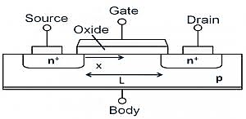

fig. 5. 8 Structure of MOSFET.

**The MOSFET can function in two ways**

* Depletion Mode
* Enhancement Mode

**Depletion Mode:**

When there is no voltage on the gate, the channel shows its maximum conductance. As the voltage on the gate is either positive or negative, the channel conductivity decreases.

[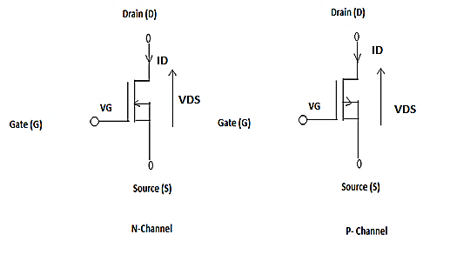](https://www.elprocus.com/wp-content/uploads/2012/09/Deflection-mode.png)

fig. 5. 9 Operations in Depletion Mode.

**Enhancement mode:**

When there is no voltage on the gate the device does not conduct. More is the voltage on the gate, the better the device can conduct.

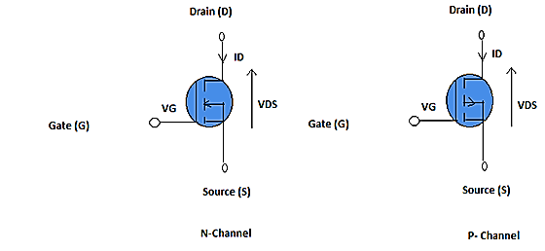

fig. 5. 10 Operation in Enhancement Mode.

### 5.3.1 WORKING PRINCIPLE OF MOSFET

The aim of the MOSFET is to be able to control the voltage and current flow between the source and drain. It works almost as a switch. The working of MOSFET depends upon the MOS capacitor. The MOS capacitor is the main part of MOSFET. The semiconductor surface at the below oxide layer which is located between source and drain terminal. It can be inverted from p-type to n-type by applying a positive or negative gate voltage respectively.  When we apply the positive gate voltage the holes present under the oxide layer with a repulsive force and holes are pushed downward with the substrate. The depletion region populated by the bound negative charges which are associated with the acceptor atoms. The electrons reach channel is formed. The positive voltage also attracts electrons from the n+ source and drain regions into the channel. Now, if a voltage is applied between the drain and source, the current flows freely between the source and drain and the gate voltage controls the electrons in the channel. Instead of positive voltage if we apply negative voltage, a hole channel will be formed under the oxide layer.

[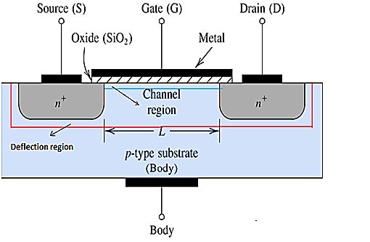](https://www.elprocus.com/wp-content/uploads/2012/09/MOSFET-BLOCK-DIAGRAM.png)

fig. 5. 11 MOSFET Block Diagram.

### 5.3.2 N- CHANNEL MOSFET

The N-Channel MOSFET has a N- channel region between source and drain It is a four terminal device such as gate, drain, source, body. This type of MOSFET the drain and source are heavily doped n+ region and the substrate or body is P- type. The current flows due to the negatively charged electrons. When we apply the positive gate voltage the holes present under the oxide layer pushed downward into the substrate with a repulsive force. The depletion region is populated by the bound negative charges which are associated with the acceptor atoms. The electrons reach channel is formed. The positive voltage also attracts electrons from the n+ source and drain regions into the channel. Now, if a voltage is applied between the drain and source the current flows freely between the source and drain and the gate voltage controls the electrons in the channel. Instead of positive voltage if we apply negative voltage a hole channel will be formed under the oxide layer.

### 5.3.3 IRF840 MOSFET

IRF840 is rated for 8a, 500v, 0.850-ohm, n-channel power mosfet this n-channel enhancement mode silicon gate power field effect transistor is an advanced power mosfet designed, tested, and guaranteed to withstand a specified level of energy in the breakdown avalanche mode of operation. all of these power mosfets are designed for applications such as switching regulators, switching converters, motor drivers, relay drivers, and drivers for high power bipolar switching transistors requiring high speed and low gate drive power. These types can be operated directly from integrated circuits. Formerly developmental type TA17425.

**Features**

* It belongs to the N channel family of MOSFET.
* The value of drain to source voltage used for breakdown is five hundred volts.
* The value of drain current for this MOSFET is eight amperes.
* It exists in the To-220 packaging.
* The value of the gate threshold voltage is ten volts.
* The value of rise time is twenty-three nS and the fall time is twenty Nano seconds.
* The value of drain to source resistance is 0.85ohms.

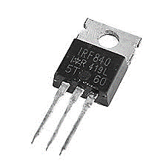

Fig.5. 12 IRF840 MOSFET.

## 5.4 INDUCTOR

The Inductor, also called a choke, is another passive type electrical component which is just a coil of wire that is designed to take advantage of this relationship by inducing a magnetic field in itself or in the core as a result of the current passing through the coil. This results in a much stronger magnetic field than one that would be produced by a simple coil of wire.

Inductors are formed with wire tightly wrapped around a solid central core which can be either a straight cylindrical rod or a continuous loop or ring to concentrate their magnetic flux.

The schematic symbol for a inductor is that of a coil of wire so therefore, a coil of wire can also be called an Inductor. Inductors usually are categorised according to the type of inner core they are wound around, for example, hollow core (free air), solid iron core or soft ferrite core with the different core types being distinguished by adding continuous or dotted parallel lines next to the wire coil as shown below.

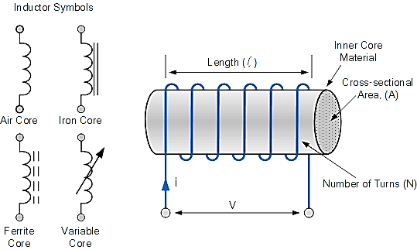

fig. 5. 13 Symbol of Inductor.

The current, i that flows through an inductor produces a magnetic flux that is proportional to it. But unlike a Capacitor which oppose a change of voltage across their plates, an inductor opposes the rate of change of current flowing through it due to the build-up of self-induced energy within its magnetic field.

In other words, inductors resist or oppose changes of current but will easily pass a steady state DC current. This ability of an inductor to resist changes in current and which also relates current, i with its magnetic flux linkage, NΦ as a constant of proportionality is called Inductance which is given the symbol L with units of Henry, (H) after Joseph Henry.

Because the Henry is a relatively large unit of inductance in its own right, for the smaller inductors sub-units of the Henry are used to denote its value.

|  |  |  |  |
| --- | --- | --- | --- |
| Prefix | Symbol | Multiplier | Power of Ten |
| Milli | M | 1/1,000 | 10-3 |
| micro | µ | 1/1,000,000 | 10-6 |
| nano | N | 1/1,000,000,000 | 10-9 |

Table 2: Inductance Prefixes

So, to display the sub-units of the Henry we would use as an example:

* 1mH = 1 milli-Henry – which is equal to one thousandth’s (1/1000) of a Henry.
* 100uH = 100 micro-Henries – which is equal to 100 millionth’s (1/1,000,000) of a Henry.

Inductors or coils are very common in electrical circuits and there are many factors which determine the inductance of a coil such as the shape of the coil, the number of turns of the insulated wire, the number of layers of wire, the spacing between the turns, the permeability of the core material, the size or cross-sectional area of the core etc, to name a few.

An inductor coil has a central core area A, with a constant number of turns of wire per unit length, l. So, if a coil of N turns is linked by an amount of magnetic flux, Φ then the coil has a flux linkage of NΦ and any current, i that flows through the coil will produce an induced magnetic flux in the opposite direction to the flow of current.

Then according to Faraday’s Law, any change in this magnetic flux linkage produces a self-induced voltage in the single coil of:

$V_{L}=N\frac{d∅}{dt}=\frac{μN^{2}A}{l}\frac{di}{dt} (4.1)$

Where:

* N is the number of turns.
* A is the cross-sectional Area in m2.
* Φ is the amount of flux in Webers.
* μ is the Permeability of the core material.
* l is the Length of the coil in meters.
* di/dt is the Currents rate of change in amps/second.

A time varying magnetic field induces a voltage that is proportional to the rate of change of the current producing it with a positive value indicating an increase in emf and a negative value indicating a decrease in emf. The equation relating this self-induced voltage, current and inductance can be found by substituting the μN2A / l with L denoting the constant of proportionality called the Inductance of the coil.

The relation between the flux in the inductor and the current flowing through the inductor is given as: Φ = Li. As an inductor consists of a coil of conducting wire, this then reduces the above equation to give the self-induced emf, sometimes called the back emf induced in the coil too.

$$V_{L}(t)=\frac{d∅}{dt}=\frac{dLi}{dt}=-L\frac{di}{dt} (4.2)$$

Where : L is the self-inductance and di/dt the rate of current change.

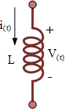  
fig 5. 14 Inductor Coil.

So, from this equation we can say that the “self-induced emf = inductance x rate of current change” and a circuit has an inductance of one Henry will have an emf of one volt induced in the circuit when the current flowing through the circuit changes at a rate of one ampere per second.

One important point to note about the above equation. It only relates the emf produced across the inductor to changes in current because if the flow of inductor current is constant and not changing such as in a steady state DC current, then the induced emf voltage will be zero because the instantaneous rate of current change is zero, di/dt = 0.

With a steady state DC current flowing through the inductor and therefore zero induced voltage across it, the inductor acts as a short circuit equal to a piece of wire, or at the very least a very low value resistance. In other words, the opposition to the flow of current offered by an inductor is very different between AC and DC circuits.

### 5.4.1 THE TIME CONSTANT OF AN INDUCTOR

We now know that the current cannot change instantaneously in an inductor because for this to occur, the current would need to change by a finite amount in zero time which would result in the rate of current change being infinite, di/dt = ∞, making the induced emf infinite as well and infinite voltages do not exist. However, if the current flowing through an inductor change very rapidly, such as with the operation of a switch, high voltages can be induced across the inductors coil.

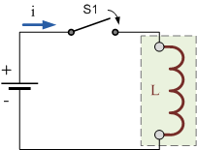

fig. 5. 15 Inductor Switching Circuit.

Consider the circuit of the inductor on the right. With the switch, (S1) open, no current flows through the inductor coil. As no current flows through the inductor, the rate of change of current (di/dt) in the coil will be zero. If the rate of change of current is zero there is no self-induced emf, (VL = 0) within the inductor coil.

If we now close the switch (t = 0), a current will flow through the circuit and slowly rise to its maximum value at a rate determined by the inductance of the inductor. This rate of current flowing through the inductor multiplied by the inductors inductance in Henry’s, results in some fixed value self-induced emf being produced across the coil as determined by Faraday’s equation above, VL = L $\frac{di}{dt}$.

This self-induced emf across the inductors coil, (VL) fights against the applied voltage until the current reaches its maximum value and a steady state condition is reached. The current which now flows through the coil is determined only by the DC or “pure” resistance of the coils windings as the reactance value of the coil has decreased to zero because the rate of change of current (di/dt) is zero in steady state. In other words, only the coils DC resistance now exists to oppose the flow of current.

Likewise, if switch, (S1) is opened, the current flowing through the coil will start to fall but the inductor will again fight against this change and try to keep the current flowing at its previous value by inducing a voltage in the other direction. The slope of the fall will be negative and related to the inductance of the coil as shown below.

### 5.4.2 CURRENT AND VOLTAGE IN AN INDUCTOR

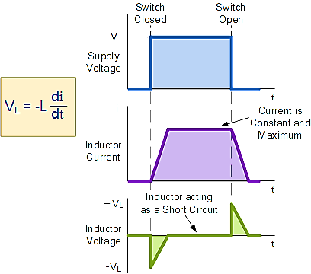

fig. 5. 16 Inductor Current and Voltage Waveform.

How much induced voltage will be produced by the inductor depends upon the rate of current change. In our tutorial about Electromagnetic Induction, Lenz’s Law stated that: “the direction of an induced emf is such that it will always opposes the change that is causing it”. In other words, an induced emf will always oppose the motion or change which started the induced emf in the first place.

So, with a decreasing current the voltage polarity will be acting as a source and with an increasing current the voltage polarity will be acting as a load. So, for the same rate of current change through the coil, either increasing or decreasing the magnitude of the induced emf will be the same.

### 5.4.3 POWER IN AN INDUCTOR

We know that an inductor in a circuit opposes the flow of current, ( i ) through it because the flow of this current induces an emf that opposes it, Lenz’s Law. Then work has to be done by the external battery source in order to keep the current flowing against this induced emf. The instantaneous power used in forcing the current, (i) against this self-induced emf, (VL) is given from above as: $V_{L(t)}=-L\frac{di}{dt} (4.3)$

Power in a circuit is given as, P = V.I therefore:

$$P=v.i=L\left(\frac{di}{dt}\right)×i=\frac{1}{2}L\left(\frac{di^{2}}{dt}\right)=\frac{d}{dt}\left[\frac{1}{2}Li^{2}\right] (4.4)$$

An ideal inductor has no resistance only inductance so R = 0 Ω’s and therefore no power is dissipated within the coil, so we can say that an ideal inductor has zero power loss.

### 5.4.4 ENERGY IN AN INDUCTOR

When power flows into an inductor, energy is stored in its magnetic field. When the current flowing through the inductor is increasing and di/dt becomes greater than zero, the instantaneous power in the circuit must also be greater than zero, (P > 0) i.e., positive which means that energy is being stored in the inductor.

Likewise, if the current through the inductor is decreasing and di/dt is less than zero then the instantaneous power must also be less than zero, (P < 0) i.e., negative which means that the inductor is returning energy back into the circuit. Then by integrating the equation for power above, the total magnetic energy which is always positive, being stored in the inductor is therefore given as:

### 5.4.5 ENERGY STORED BY AN INDUCTOR

The energy is actually being stored within the magnetic field that surrounds the inductor by the current flowing through it. In an ideal inductor that has no resistance or capacitance, as the current increases energy flows into the inductor and is stored there within its magnetic field without loss, it is not released until the current decreases and the magnetic field collapses.

$$W_{(t)}=\frac{1}{2}Li_{(t)}^{2} (4.5)$$

Where:  W is in joules, L is in Henries and “i” is in Amperes.

Then in an alternating current, AC circuit an inductor is constantly storing and delivering energy on each and every cycle. If the current flowing through the inductor is constant as in a DC circuit, then there is no change in the stored energy as P = Li(di/dt) = 0.

So, inductors can be defined as passive components as they can both stored and deliver energy to the circuit, but they cannot generate energy. An ideal inductor is classed as loss less, meaning that it can store energy indefinitely as no energy is lost.

However, real inductors will always have some resistance associated with the windings of the coil and whenever current flows through a resistance energy is lost in the form of heat due to Ohms Law, (P = I2R) regardless of whether the current is alternating or constant.

Then the primary use for inductors is in filtering circuits, resonance circuits and for current limiting. An inductor can be used in circuits to block or reshape alternating current or a range of sinusoidal frequencies, and in this role an inductor can be used to “tune” a simple radio receiver or various types of oscillators. It can also protect sensitive equipment from destructive voltage spikes and high inrush currents.

## 5.5 CAPACITOR

The capacitor is a component which has the ability or “capacity” to store energy in the form of an electrical charge producing a potential difference (*Static Voltage*) across its plates, much like a small rechargeable battery. There are many different kinds of capacitors available from very small capacitor beads used in resonance circuits to large power factor correction capacitors, but they all do the same thing, they store charge.

In its basic form, a capacitor consists of two or more parallel conductive (metal) plates which are not connected or touching each other, but are electrically separated either by air or by some form of a good insulating material such as waxed paper, mica, ceramic, plastic or some form of a liquid gel as used in electrolytic capacitors. The insulating layer between a capacitor plates is commonly called the Dielectric.

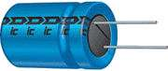

fig. 5. 17 A Typical Capacitor.

Due to this insulating layer, DC current cannot flow through the capacitor as it blocks it allowing instead a voltage to be present across the plates in the form of an electrical charge.

The conductive metal plates of a capacitor can be either square, circular or rectangular, or they can be of a cylindrical or spherical shape with the general shape, size and construction of a parallel plate capacitor depending on its application and voltage rating.

When used in a direct current or DC circuit, a capacitor charges up to its supply voltage but blocks the flow of current through it because the dielectric of a capacitor is non-conductive and basically an insulator. However, when a capacitor is connected to an alternating current or AC circuit, the flow of the current appears to pass straight through the capacitor with little or no resistance.

There are two types of electrical charge, positive charge in the form of Protons and negative charge in the form of Electrons. When a DC voltage is placed across a capacitor, the positive (+ve) charge quickly accumulates on one plate while a corresponding and opposite negative (-ve) charge accumulates on the other plate. For every particle of +ve charge that arrives at one plate a charge of the same sign will depart from the -ve plate.

Then the plates remain charge neutral and a potential difference due to this charge is established between the two plates. Once the capacitor reaches its steady state condition an electrical current is unable to flow through the capacitor itself and around the circuit due to the insulating properties of the dielectric used to separate the plates.

The flow of electrons onto the plates is known as the capacitors Charging Current which continues to flow until the voltage across both plates (and hence the capacitor) is equal to the applied voltage $V_{C}$ . At this point the capacitor is said to be “fully charged” with electrons.

The strength or rate of this charging current is at its maximum value when the plates are fully discharged (initial condition) and slowly reduces in value to zero as the plates charge up to a potential difference across the capacitors plates equal to the source voltage.

The parallel plate capacitor is the simplest form of capacitor. It can be constructed using two metal or metallized foil plates at a distance parallel to each other, with its capacitance value in Farads, being fixed by the surface area of the conductive plates and the distance of separation between them. Altering any two of these values alters the value of its capacitance and this forms the basis of operation of the variable capacitors.

Also, because capacitors store the energy of the electrons in the form of an electrical charge on the plates the larger the plates and/or smaller their separation the greater will be the charge that the capacitor holds for any given voltage across its plates. In other words, larger plates, smaller distance, more capacitance.

By applying a voltage to a capacitor and measuring the charge on the plates, the ratio of the charge Q to the voltage V will give the capacitance value of the capacitor and is therefore given as: C = Q/V this equation can also be re-arranged to give the more familiar formula for the quantity of charge on the plates as: Q = C $×$ V.

Although we have said that the charge is stored on the plates of a capacitor, it is more correct to say that the energy within the charge is stored in an “electrostatic field” between the two plates. When an electric current flows into the capacitor, charging it up, the electrostatic field becomes more stronger as it stores more energy.

Likewise, as the current flows out of the capacitor, discharging it, the potential difference between the two plates decreases and the electrostatic field decreases as the energy moves out of the plates.

The property of a capacitor to store charge on its plates in the form of an electrostatic field is called the Capacitance of the capacitor. Not only that, but capacitance is also the property of a capacitor which resists the change of voltage across it.

### 5.5.1 THE CAPACITANCE OF A CAPACITOR

Capacitance is the electrical property of a capacitor and is the measure of a capacitors ability to store an electrical charge onto its two plates with the unit of capacitance being the Farad (abbreviated to F) named after the British physicist Michael Faraday.

Capacitance is defined as being that a capacitor has the capacitance of One Farad when a charge of One Coulomb is stored on the plates by a voltage of One volt. Note that capacitance, C is always positive in value and has no negative units. However, the Farad is a very large unit of measurement to use on its own so sub-multiples of the Farad are generally used such as micro-farads, nano-farads and pico-farads.

**Standard Units of Capacitance**

* Microfarad (μF) =1μF = 1/1,000,000 = 0.000001 = 10-6 F
* Nanofarad (nF) =1nF = 1/1,000,000,000 = 0.000000001 = 10-9 F
* Picofarad (pF) =1pF = 1/1,000,000,000,000 = 0.000000000001 = 10-12 F

Then using the information above we can construct a simple table to help us convert between pico-Farad (pF), to nano-Farad (nF), to micro-Farad (μF) and to Farads (F) as shown.

**Capacitance of a Parallel Plate Capacitor**

The capacitance of a parallel plate capacitor is proportional to the area, A in metres2 of the smallest of the two plates and inversely proportional to the distance or separation, (d) (i.e., the dielectric thickness) given in metres between these two conductive plates.

The generalised equation for the capacitance of a parallel plate capacitor is given as: C = ε(A/d) where ε represents the absolute permittivity of the dielectric material being used. The permittivity of a vacuum, εo also known as the “permittivity of free space” has the value of the constant 8.84 x 10-12 Farads per metre.

To make the maths a little easier, this dielectric constant of free space, εo, which can be written as: 1 / (4π x 9×109), may also have the units of picofarads (pF) per metre as the constant giving: 8.84 for the value of free space. Note though that the resulting capacitance value will be in picofarads and not in farads.

Generally, the conductive plates of a capacitor are separated by some kind of insulating material or gel rather than a perfect vacuum. When calculating the capacitance of a capacitor, we can consider the permittivity of air, and especially of dry air, as being the same value as a vacuum as they are very close.

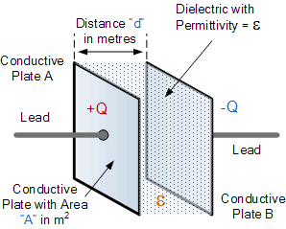

fig. 5. 18 Parallel Plate Capacitor

* **The Dielectric of a Capacitor**

As well as the overall size of the conductive plates and their distance or spacing apart from each other, another factor which affects the overall capacitance of the device is the type of dielectric material being used. In other words, the “Permittivity” (ε) of the dielectric.

The conductive plates of a capacitor are generally made of a metal foil or a metal film allowing for the flow of electrons and charge, but the dielectric material used is always an insulator. The various insulating materials used as the dielectric in a capacitor differ in their ability to block or pass an electrical charge.

This dielectric material can be made from a number of insulating materials or combinations of these materials with the most common types used being: air, paper, polyester, polypropylene, Mylar, ceramic, glass, oil, or a variety of other materials.

The factor by which the dielectric material, or insulator, increases the capacitance of the capacitor compared to air is known as the Dielectric Constant, k and a dielectric material with a high dielectric constant is a better insulator than a dielectric material with a lower dielectric constant. Dielectric constant is a dimensionless quantity since it is relative to free space.

The actual permittivity or “complex permittivity” of the dielectric material between the plates is then the product of the permittivity of free space (εo) and the relative permittivity (εr) of the material being used as the dielectric and is given as:

Complex Permittivity

$ε=ε_{o}+ε_{r} (4.6)$

In other words, if we take the permittivity of free space, εo as our base level and make it equal to one, when the vacuum of free space is replaced by some other type of insulating material, their permittivity of its dielectric is referenced to the base dielectric of free space giving a multiplication factor known as “relative permittivity”, εr. So, the value of the complex permittivity, ε will always be equal to the relative permittivity times one.

Typical units of dielectric permittivity, ε or dielectric constant for common materials are: Pure Vacuum = 1.0000, Air = 1.0006, Paper = 2.5 to 3.5, Glass = 3 to 10, Mica = 5 to 7, Wood = 3 to 8 and Metal Oxide Powders = 6 to 20 etc.

This then gives us a final equation for the capacitance of a capacitor as:

Capacitance, C = $\frac{ε_{o}ε_{r}A}{d}$ Farads (4.7)

One method used to increase the overall capacitance of a capacitor while keeping its size small is to “interleave” more plates together within a single capacitor body. Instead of just one set of parallel plates, a capacitor can have many individual plates connected together thereby increasing the surface area, A of the plates.

For a standard parallel plate capacitor as shown above, the capacitor has two plates, labelled A and B. Therefore, as the number of capacitor plates is two, we can say that n = 2, where “n” represents the number of plates.

Then our equation above for a single parallel plate capacitor should really be:

Capacitance, C = $\frac{ε_{o}ε_{r}(n-1)A}{d}$ Farads (4.8)

### 5.5.2 VOLTAGE RATING OF A CAPACITOR

All capacitors have a maximum voltage rating and when selecting a capacitor consideration must be given to the amount of voltage to be applied across the capacitor. The maximum amount of voltage that can be applied to the capacitor without damage to its dielectric material is generally given in the data sheets as: WV, (working voltage) or as WV DC, (DC working voltage).

If the voltage applied across the capacitor becomes too great, the dielectric will break down (known as electrical breakdown) and arcing will occur between the capacitor plates resulting in a short-circuit. The working voltage of the capacitor depends on the type of dielectric material being used and its thickness.

The DC working voltage of a capacitor is just that, the maximum DC voltage and NOT the maximum AC voltage as a capacitor with a DC voltage rating of 100 volts DC cannot be safely subjected to an alternating voltage of 100 volts. Since an alternating voltage has an r.m.s. value of 100 volts but a peak value of over 141 volts.

Then a capacitor which is required to operate at 100 volts AC should have a working voltage of at least 200 volts. In practice, a capacitor should be selected so that its working voltage either DC or AC should be at least 50 percent greater than the highest effective voltage to be applied to it.

Another factor which affects the operation of a capacitor is Dielectric Leakage. Dielectric leakage occurs in a capacitor as the result of an unwanted leakage current which flows through the dielectric material.

Generally, it is assumed that the resistance of the dielectric is extremely high and a good insulator blocking the flow of DC current through the capacitor (as in a perfect capacitor) from one plate to the other.

However, if the dielectric material becomes damaged due excessive voltage or over temperature, the leakage current through the dielectric will become extremely high resulting in a rapid loss of charge on the plates and an overheating of the capacitor eventually resulting in premature failure of the capacitor. Then never use a capacitor in a circuit with higher voltages than the capacitor is rated for otherwise it may become hot and explode.

## 5.6 HARDWARE VIEW

Fig 35.19 shows the hardware implementation of the proposed converter. The construction consists of transformers which is connected to the full-bridge rectifier circuits, one is used as an input to the a dual-switch high step-up DC-DC converter with CI and SC cells and another is the input of the microcontroller and gate driver circuit. The proposed converter has power switches (MOSFETS) to control then we make use of MOSFET driver circuit (TLP350 gate driver circuit). To control gate pulse signal of the power switches with help of microprocessor DSPIC30f2010 we generate gate pulse.

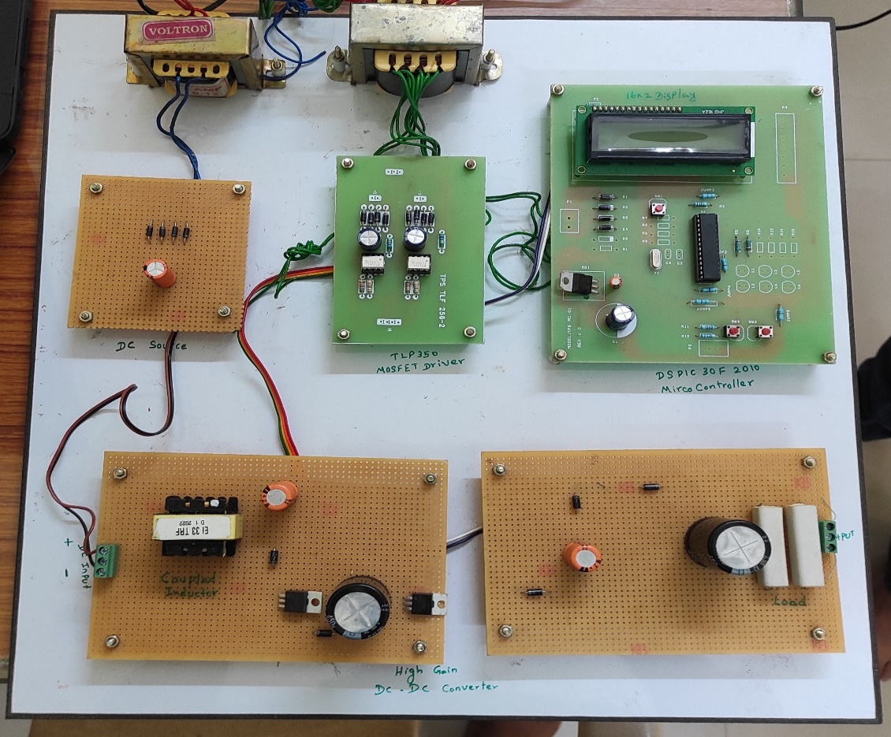

fig. 5. 19 Hardware View

### 5.6.1 HARWARE RESULTS

Fig 5.19 has been tested in order to demonstrate the validity of the proposed converter a dual-switch high step-up DC-DC converter with CI and SC cells which is fabricated. The switching frequency is 100KHz with a duty cycle of 37.5%. The input voltage of the converter is 8.7 V which is shown in the below fig 5.20. The Output voltage of the proposed converter is 95.7V, which is shown in fig 5.21.

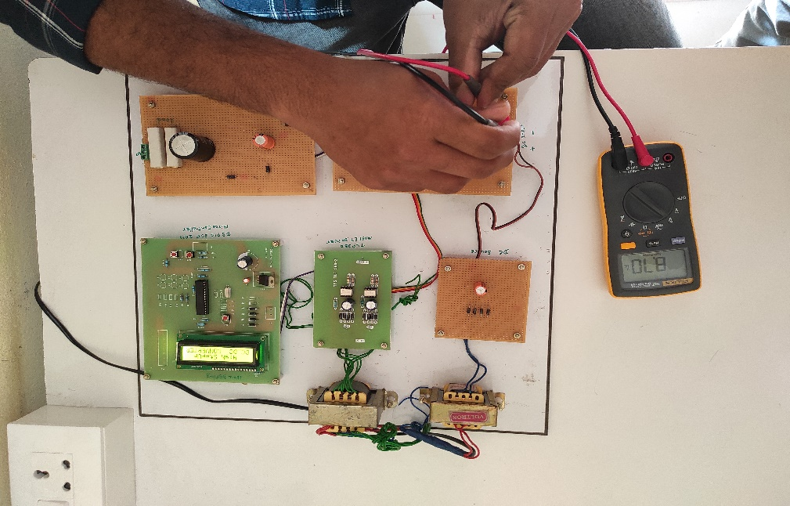

fig. 5. 20 Input Voltage of The Proposed Converter.

In a dual switch coupled inductor-based DC to DC converter, an input voltage of 8.7 V can be used to convert the voltage to a higher voltage level depending on the application requirement. The converter operates by switching the current flow in the inductor through the use of two switches, which results in a high voltage conversion ratio.

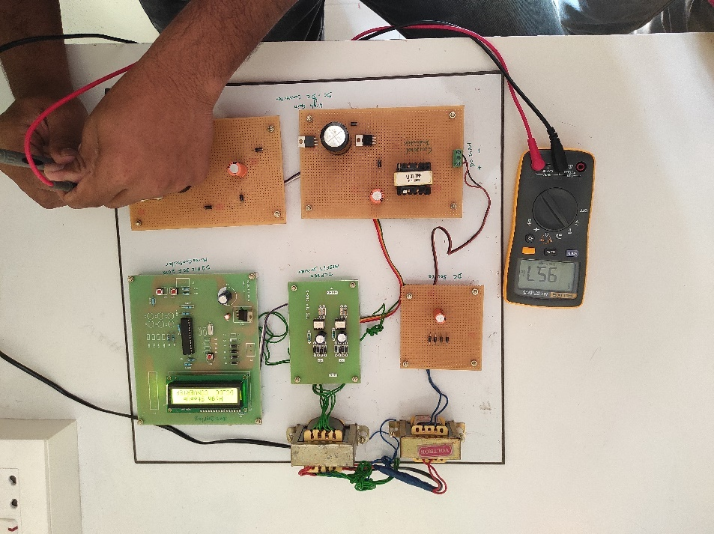

fig. 5. 21 Output Voltage of The Proposed Converter.

The duty cycle and switching frequency are critical parameters in the operation of the converter, as they determine the output voltage level and the efficiency of the conversion process. The proposed converter has an input voltage of 8.7V with a duty cycle of 37.5 and switching frequency of 100Khz can be used to step up the voltage to an output voltage of 95V. The converter operates by switching the current flow in the inductor through the use of two switches, which results in a high voltage conversion ratio. The duty cycle of 37.5% means that the switches are closed for 37.5% of the switching period, and open for the remaining 62.5%. The switching frequency of 100Khz ensures that the converter can operate efficiently and with a high level of accuracy.

## 5.7 CHAPTER CONCLUSION

The dual switch coupled inductor-based DC to DC converter has been successfully designed and implemented for hardware, with an input voltage of 8.7V and an output voltage of 95V, achieving a gain of 10.92%. The converter employs two switches, coupled inductors, and a capacitor to achieve high efficiency and low output ripple. The design process involved selecting appropriate components, PCB layout design, and testing of the converter circuit. The hardware implementation has demonstrated the effectiveness of the design, with excellent performance in terms of efficiency, output ripple, and transient response. The dual switch coupled inductor-based DC to DC converter is a reliable and efficient solution for voltage conversion applications.

## CONCLUSION

In this project a dual-switch high step-up DC-DC converter with CI and SC cells is simulated and hardware is designed. The proposed converter achieves a high-voltage gain and low current and voltage stresses on the power switches. Thus, a low-voltage-rating MOSFETs with low RDS(ON) can be used, which helps to the reduction of power losses and the improvement of efficiency. The output diode turns off under ZCS condition, resulting in the suppression of reverse-recovery problems and further improved efficiency. Steady-state analysis and operation principle in CCM of the proposed topology were presented.

# 

## **REFERENCES**

1. Axelrod, Y. Berkovich, and A. Ioinovici, "Switched Capacitor/Switched-Inductor Structures for Getting Transformerless Hybrid DC–DC PWM Converters," IEEE Transactions on Circuits and Systems I: Regular Papers, vol. 55, pp. 687-696, 2008.
2. H. Liu, F. Li, and J. Ai, "A Novel High Step-Up Dual Switches Converter with Coupled Inductor and Voltage Multiplier Cell for a Renewable Energy System," IEEE Transactions on Power Electronics, vol. 31, pp. 4974-4983, 2016.
3. B. Poorali, A. Torkan, and E. Adib, "High step-up Z-source DC–DC converter with coupled inductors and switched capacitor cell," IET Power Electronics, vol. 8, pp. 1394-1402, 2015.
4. A. Samadian, S. H. Hosseini, M. Sabahi, and M. Maalandish, "A New Coupled Inductor Nonisolated High Step-Up Quasi Z-Source DC–DC Converter," IEEE Transactions on Industrial Electronics, vol. 67, pp. 5389-5397, 2020.
5. F. Evran and M. T. Aydemir, "Z-source-based isolated high step-up converter," IET Power Electronics, vol. 6, pp. 117-124, 2013.
6. H. Liu, H. Hu, H. Wu, Y. Xing, and I. Batarseh, "Overview of High Step-Up Coupled-Inductor Boost Converters," IEEE Journal of Emerging and Selected Topics in Power Electronics, vol. 4, pp. 689-704, 2016.
7. S. Sadaf, M. S. Bhaskar, M. Meraj, A. Iqbal, and N. Al-Emadi, "A Novel Modified Switched Inductor Boost Converter with Reduced Switch Voltage Stress," IEEE Transactions on Industrial Electronics, vol. 68, pp. 1275-1289, 2021.
8. R. Rahimi, M. Farhadi, G. R. Moradi, B. Farhangi and S. Farhangi,"Filter-Clamped Two-Level Three-Phase Transformerless Grid-Connected Photovoltaic Inverter for Leakage Current Reduction," 2020 IEEE Kansas Power and Energy Conference (KPEC), Manhattan, KS,USA, pp. 1-6, 2020.
9. H. Moradisizkoohi, N. Elsayad, and O. A. Mohammed, "Ultra-High Step-Up DC/DC Converter Based on Dual-Coupled-Inductors with Low Voltage Stress and Input Current Ripple for Renewable Energy Applications," in 2019 IEEE Applied Power Electronics Conference and Exposition (APEC), pp. 2171-2176, 2019.
10. M. S. Bhaskar, R. Alammari, M. Meraj, S. Padmanaban, and A. Iqbal,"A New Triple-Switch-Triple-Mode High Step-Up Converter WithWide Range of Duty Cycle for DC Microgrid Applications," IEEE Transactions on Industry Applications, vol. 55, pp. 7425-7441, 2019.
11. F. M. Shahir, E. Babaei, and M. Farsadi, "Voltage-Lift Technique Based Nonisolated Boost DC–DC Converter: Analysis and Design," IEEE Transactions on Power Electronics, vol. 33, pp. 5917-5926, 2018.
12. A. Torkan and M. Ehsani, "A Novel Nonisolated Z-Source DC–DC Converter for Photovoltaic Applications," IEEE Transactions on Industry Applications, vol. 54, pp. 4574-4583, 2018.
13. S. Salehi, N. Zahedi, R. Kheirollahi, and E. Babaei, "Ultra High Step-up DC-DC Converter Based on Switched Inductor-Capacitor Cells," in 2019 10th International Power Electronics, Drive Systems and Technologies Conference (PEDSTC), pp. 367-372, 2019.
14. V. M. Pacheco, A. J. d. Nascimento, V. J. Farias, J. B. Vieira, and L. C.d. Freitas, "A quadratic buck converter with lossless commutation," IEEE Transactions on Industrial Electronics, vol. 47, pp. 264-272, 2000.
15. N. Vosoughi Kurdkandi, M. Farhadi, E. Babaei, and P. Ghavidel, "Design and analysis of a switched-capacitor DC-DC converter with variable conversion ratio," International Journal of Circuit Theory and Applications, vol. 48, pp. 1638-1657, 2020.
16. B. P. Baddipadiga and M. Ferdowsi, "A high-voltage-gain dc-dc converter based on modified dickson charge pump voltage multiplier," IEEE Transactions on Power Electronics, vol. 32, pp. 7707-7715, 2017.
17. V. A. K. Prabhala, P. Fajri, V. S. P. Gouribhatla, B. P. Baddipadiga, and M. Ferdowsi, "A DC–DC Converter With High Voltage Gain and Two Input Boost Stages," IEEE Transactions on Power Electronics, vol. 31, pp. 4206-4215, 2016.
18. T. Yao, C. Nan, and R. Ayyanar, "A New Soft-Switching Topology for Switched Inductor High Gain Boost," IEEE Transactions on Industry Applications, vol. 54, pp. 2449-2458, 2018.
19. B. Faridpak, M. Bayat, M. Nasiri, R. Samanbakhsh, and M. Farrokhifar, "Improved Hybrid Switched Inductor/Switched Capacitor DC–DC Converters," IEEE Transactions on Power Electronics, vol. 36, pp. 3053-3062, 2021.
20. K. Zaoskoufis and E. C. Tatakis, "An Improved Boost-based DC/DC Converter with High Voltage step-up ratio for DC Microgrids," IEEE Journal of Emerging and Selected Topics in Power Electronics, 2020.
21. M. Lakshmi, S. Hemamalini, “Nonisolated High Gain DC–DCConverter for DC Microgrids,” IEEE Trans. on Ind. Electron., vol. 65, no. 2, pp. 1205–1212, Feb. 2018.
22. E. Babaei, H. M. Maheri, M. Sabahi, S. H. Hosseini, “Extendable Nonisolated High Gain DC–DC Converter Based on Active–Passive Inductor Cells,” IEEE Trans. on Ind. Electron., vol. 65, no. 12, pp. 9478–9487, Dec. 2018.
23. **G. Chu, D. Lu, and V. Agelidis, “Flyback-based high step-up converter with reduced power processing stages,” IET Power Electronics, vol. 5, no. 3, pp. 349–357, 2012.**
24. Y.-P. Hsieh, J.-F. Chen, T.-J. Liang, and L.-S. Yang, “Analysis and implementation of a novel single-switch high step-up dc-dc converter,” IET Power Electronics, vol. 5, no. 1, pp. 11–21, 2012.
25. A. Torkan, “Design, simulation and implementation of a high step-up z-source dc-dc converter with flyback and voltage multiplier,” Master’s thesis, Texas A&M University, 2016.
26. NPTEL COURSE on Advance power electronics and Control, IIT Roorkee by Prof. Avik Bhattacharya https://nptel.ac.in/courses/108107128.